If you are using a Samsung phone or Tablet and want to use
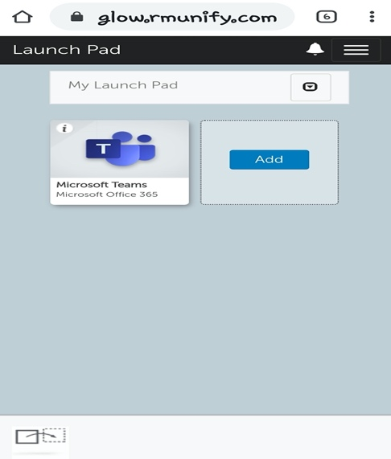
Microsoft Teams, follow steps below......

- Log in to your GLOW Launch Pad.

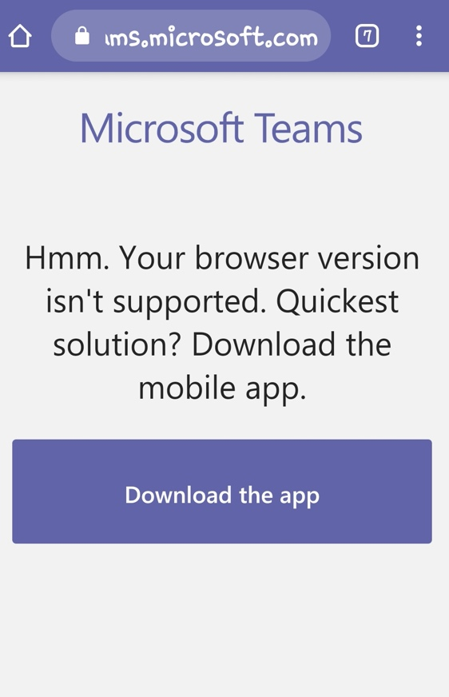
- Click on TEAMS.
- The following message will come up.

- Click on these and go to DOWNLOADS.
- This takes you to the TEAMS app that you can download.
- If Not, go to Playstore, and download from there.

