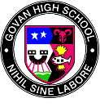
CORONA VIRUS – SELF ISOLATION
Accessing Learning and Revision Materials on GLOW
If you are on a desktop then please follow the instructions below:

In the event of pupils having to self-isolate we are working hard to make sure pupils have access to materials to allow them to study at home.

- Subject areas have issued study packs/past papers to pupils
- Staff from different subject areas have also uploaded materials to GLOW Teams

Accessing GLOW Teams:
- Pupils should log into their GLOW account. (This can be accessed from any ICT device ie pc, laptop, phone, ipad).
- This can be accessed by clicking here: https://glow.rmunify.com/
- Choose the email tile
- Choose the icons shown below

SQA Website
Senior pupils should also work through past papers and check the marking instructions on the SQA website:
https://www.sqa.org.uk/pastpapers/findpastpaper.htm

If you are on a mobile device then please follow the instructions below:

Once you log on to GLOW the ‘Microsoft Teams’ tile might not be visible on your ‘launch pad. If this is the case then please follow the following steps…
Click on this icon and then select ‘App Library’

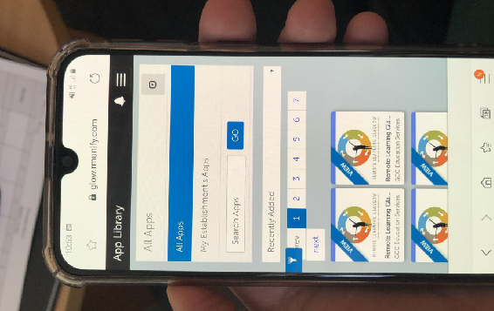
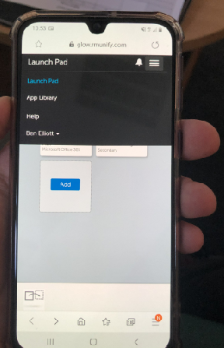
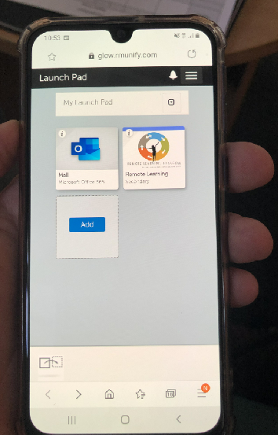
‘Microsoft Teams’ tile not visible on your ‘launch pad
Click on this icon and from the drop down menu select ‘My Establishment Apps’
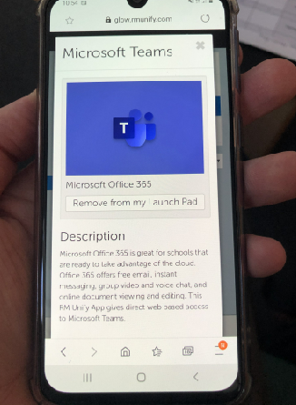
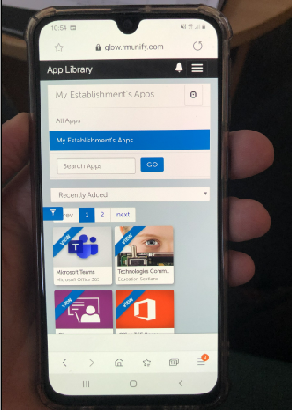
Staying in Touch

If pupils forget their GLOW log-in or password they should phone:

Govan High School landline – 0141 582 0090
Glow Helpline Number – 07707201497

If pupils need any help or have any questions they can email teachers from their GLOW account.

On this screen you will be asked to ‘add’ this application (tile) to your ‘Launch Pad’. Next time you open GLOW, Microsoft Teams will be available from the launch pad.
This will now display the applications available. Select ‘Microsoft Teams’

