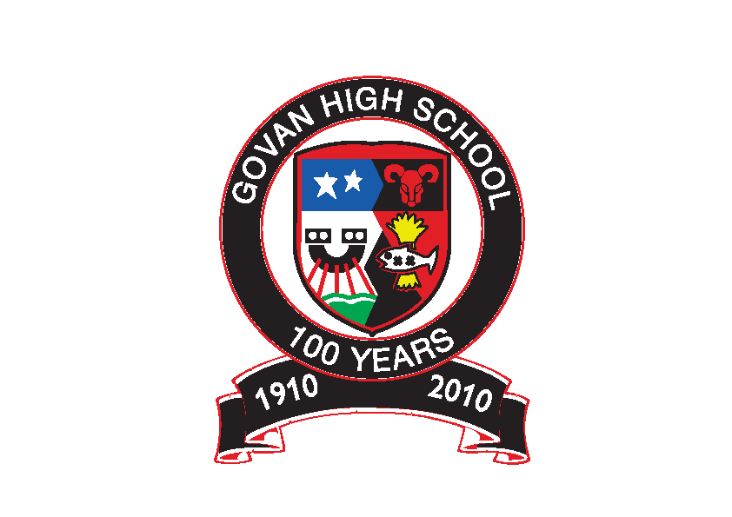Govan High School

Recovery Plan – August 2020

Advice to Pupils & Parents

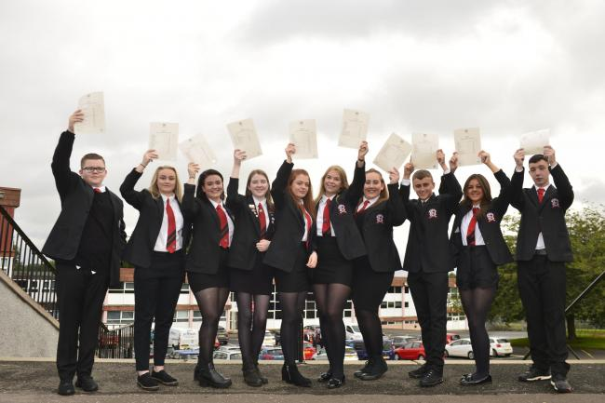

Dear Student and Parent/Carer
I hope that you and those around you are safe and well.
Since the announcement of a return to school for pupils across Scotland in August2020, we have been working hard behind the scenes to plan what this might look like for each and every one of our young people.
This process has involved us keeping health and safety advice very much at the forefront of our plans to ensure a safe return to school for all. We have had to consider the size of the building with social distancing measures in place along with the number of teachers that we have available to teach the smaller class sizes that we have had to put in place.
If the current advice from the Scottish Government and Glasgow City Council remains, then young people will return to school on a part time basis from Wednesday 12 August. It is anticipated that, when school resumes in August, the way in which young people learn will be different as a result. Learning experiences will be a mixture of learning remotely at home and learning in a normal classroom environment. This approach is known as ‘blended learning’ and will sometimes be referred to as ‘distance or remote learning’.
This document takes you through what the return to school in August will look like. We hope that you find this advice useful and reassuring.

Over the summer, stay safe, stay well and reach out to us if you need us.

Mrs Belford
Headteacher

Health and Safety
Health and Safety is first and foremost as we return to school.

Risk Assessments
We have carried out a full risk assessment for the return of staff and young people to Govan High School in August. Some young people due to health or social and emotional reasons will need to have their own risk assessment specific to them. If this is the case then Pastoral Care or the Year Head will be in touch with individual families to discuss, prior to starting in August.

Class Size
We have measured all classrooms taking into account the 2 metre safe distancing rule. All of our classes can safely accommodate 10 young people at a time. Staff have been in preparing over the month of June for a safe return to school and have ensured that their classrooms are set up to allow for social distancing. When young people come into class they will be assigned their own desk which will be 2 metres away from other young people in the class. It is important that when in school and in the classroom that all young people observe this 2 metre distancing rule.

Part Time Timetable
As a result of the social distancing measures we are putting in place, all young people will return on a part time timetable. This will vary depending on the year group that they are in. Additional information about days in school can be found later in this hand out.

Steps in place to keep you and everyone else safe around the school
- Physical distancing of 2m applies to all in the building, staff and pupils
- To limit movement and potential contact around the school, a one way system that must be followed at all times has been put in place
- There will be no clubs, supported study or parents nights initially
- Toilets to be one person at a time to maintain social distancing
- You must wash your hands regularly, especially when you enter the building. Your teachers will encourage you to do this regularly
- Hand sanitizer will be available at all entrances
- The resources used in each class will be limited to minimise cross contact
- All resources will be wiped clean after use. Disinfectant wipes will be available to allow this to happen. Young people must take responsibility to do this
- Young people should bring their own pen/ pencil. If they do not have one, they will be given one by their teacher and they should keep that
- There will be signs around the school and in the toilets to remind you of the Dos and Don’ts

Displaying COVID-19
If a young person shows COVID-19 symptoms, they should let a member of staff, or their parent/ guardian know. If anyone in the family is displaying symptoms then parents must let the school know straight away.

Drop off and pick up
There will be staggered start and finish times, as well as break and lunch times.
Pupils will not be allowed in the school building until their designated start time. When pupils come in to school they will go immediately to their first class
We will use both entrances (Mallaig Rd and Ardnish St) to assist physical distancing and overcrowding. Young people will be told on the first day back which entrance they should use and should be dropped off/arrive at the correct gate.
Parents/guardians should not access the school premise without prearrangement

Break and lunch times
These will be staggered to minimise contact with larger groups. Free school meals will be provided for those in receipt of this. Young people will also have the option to buy food in the fuel zone at lunchtime.
Please note however that there will be no provision to buy food at break time and the vending machines will not be in operation. To minimise cross contamination, young people will not be permitted to leave the school at break time and should bring a snack with them for break. There will be designated areas for young people at break time.
Those wishing to stay in school over lunch, and who are not in receipt of a free school lunch or purchasing lunch in the fuel zone, should bring a packed lunch with them. An area of the school will be allocated for packed lunch provision. Those not willing to remain in school should go home for lunch. Parents should discourage young people from going to the shops and ensure that they go directly home for lunch. If a young person goes home for lunch, they will not have access to the building until the end of lunchtime and should not return until the end of the lunch break.

Uniform & School Bag
As clothing should be washed daily, the uniform from August will be black trousers/skirt and a white shirt, with black jumper or cardigan. For this reason, until restrictions are lifted, young people should not wear ties or blazers to school. Young people can bring a school bag to school but only carrying essential items.

Bubble Groupings and Classrooms
To help ensure the safety of all we have arranged young people into ‘bubble’ groupings of 10 and they will be taught in ‘bubble’ classrooms as far as we possibly can in S1 to S4. This is mainly for English, Maths and Social Subjects. This means that teachers will move between the classrooms and not the other way round. This allows us to reduce the traffic in the corridors and limit the number of people that we all come into contact with.

Physical Education
Since the announcement of school closures due to COVID-19, the PE department have been planning a new curriculum in line with government and local authority guidelines. This has proved challenging due to the two metre social distancing guidelines, however we have been as creative as possible to continue to deliver quality physical education. Currently we are exploring activities that we can deliver outside, such as athletics, cross country running, fitness, orienteering, skill based performance training and cycling. The safety of our young people will be our main priority, therefore new procedures will be put in place when arriving and leaving the department.

Supporting our Young People Back to School

We are very aware that this has been a very abnormal time for young people and that they may have many anxieties about returning to school and about the impact that part time learning will have. We will do our utmost to support our young people as they return to school in August.
Young people will be offered a variety of supports by pastoral care and pupil support to help ease them back in to school life. The mental health and well-being of our young people is vital.
Health & Wellbeing when young people return to school will focus on resilience, helping them to understand the pandemic and feel comfortable asking questions. We are also developing questionnaires for young people around the return to school, asking what would make them feel safe and happy in school.

When young people return to school, they will have a 1-2-1 interview with either their Pastoral Care teacher or mentor to discuss any concerns that they may have and to look at any additional support that they might need. We will also work with other agencies, e.g. our counsellor, Quarriers, Lifelink, to tailor any support that young people might need.

Careers Support Next Session
The Next Steps Team at Govan High School’s aim is to help young people realise their career aspirations. We will continue to offer careers support and guidance to our young people, especially to pupils in the Senior Phase.
How will we continue to give career support to young people?
- All pupils in S5 and S6 have a timetabled ‘Pathways’ class. During this class, young people will discuss and finalise their career plans, create a personal statement, create a CV, apply for University/College/Modern Apprenticeship/Training.

- All new S6 pupils have been allocated a member of staff from the Next Steps Team who has been keeping in touch during lockdown to continue work on personal statements, virtual work placements, career programmes and they will continue to support them throughout the year in order to secure an appropriate positive destination.

- Due to the current situation, normal Work Experience Placements are unlikely to be available for the next while. However, there are a range of on-line and virtual opportunities available and Miss Arshad will continue to email information to young people and pass on information during Pathways classes.

- Over the years, we have built up many strong partnerships including: Marriott, DYW, Scottish Water, GHA, Focus West, MCR Pathways, Action for Children etc and they will continue to offer opportunities, albeit, online/virtual until we go back to our normal working pattern.

- Over the past few months, the Next Steps Team have continued to support our current leavers into destinations. Sheena, our Careers Advisor and Scott Smith, our Rangers Charity Hub Officer will continue to contact our leavers over the summer to offer support.

- Sheena will offer 1:1 coaching guidance by phone/online for all senior phase pupils throughout the year.

SDS Careers Contact Information
- Enhanced Helpline available for pupils and parents 0800 917 8000

The Structure of the School Week
The school week will look different for each group of young people as young people will attend school on different days of the week. To accommodate the changes we are making, Monday for some will become a 7 period day.

S1 – the year group has been split into 2 groups with half attending on Monday, Tuesday and Wednesday morning. The second half will attend Wednesday afternoon, Thursday and Friday.
S2 – the year group has been split into 2 groups with half attending on Monday, Tuesday and Wednesday morning. The second half will attend Wednesday afternoon, Thursday and Friday.
S3 – the year group has been split into 2 groups with half attending on the Monday and Tuesday, the second half attending on Thursday and Friday. Every second week they will attend on either the Wednesday morning or afternoon, for additional time in some of their subject areas.
S4 – the full year group will attend school on a Monday and a Tuesday. Every second week they will also attend school partially on a Wednesday to receive additional time in some of their chosen subjects.
S5/6 – the full year group will attend on a Wednesday, Thursday and Friday.

Staggered Break and Lunch
For S2, S4 and S5/6 – Break time will be 10.30-10.45 and lunch from 12.20-1ppm
For S1 and S3 - Break time will be 11.20-11.35am and lunch from 12.40-1.15pm

S1
S1 has been split into 2 groups. One half will attend at the start of the week and the other half at the end of the week. All young people will be placed into ‘bubble’ groups of 10 and will attend their subject areas in these groups. Pastoral Care and Miss Wlosinski have worked hard along with the primary teachers to arrange this split and the groups of 10.
Young people will receive two periods of both English and Maths. They will also receive a period of Heath & Wellbeing, Social Subjects, Spanish and two periods of PE. They will have 3 periods of Project Based Learning which will involve input from lots of different subjects.
Art, Home Economics, Science, Technology, IT and Music will be delivered on a 6 week rotation and young people will receive a double period of these subjects every 6 weeks.
Start and finish times will vary depending on which class each young person is in. However all young people will receive the same number of periods across the course of the week.
Monday, Tuesday and Wednesday Morning Timings
Monday 9.40am – 2.50/3.40pm Tuesday 9.40am – 2.50/3.40pm Wednesday 8.50am – 11.35am
Wednesday Afternoon, Thursday and Friday Timings
Wednesday 1.10pm-3.40pm Thursday 8.50/9.40am – 2/2.50pm Friday – 8.50am – 2.50pm
Letters are being posted out which will let you know the group that you are in, the days of the week you will be in school and the times each day. This letter will also give you details of the arrangements for the first week back at school and when you should attend that week.
Example S1 Timetable – Group A – Attending Monday, Tuesday and Wednesday Morning
 | Period 1  8.50 -9.40 | Period 2  9.40-10.30 | Period 3  10.30 – 11.20 | B  R  E  A  K | Period 4  11.35 -12.40 | L  U  N  C  H | Period 5  1.15 – 2pm | Period 6  2 – 2.50pm | Period 7  2.50 – 3.40pm
Monday |  | Social Subjects | English |  | Maths |  | Rotation | Rotation
Tuesday |  | Project Learning | Project Learning |  | Project Learning |  | H&WB | PE | PE
Wednesday | Maths | Spanish | English
Thursday
Friday
S2
S2 has been split into 2 groups. One half will attend at the start of the week and the other half at the end of the week. Pastoral Care and Miss Wlosinski have worked hard along with your teachers to arrange this split and the groups of 10 that young people will find themselves in.
Young people will receive two periods of both English and Maths. They will also receive a period of Heath & Wellbeing, Social Subjects, Spanish and two periods of PE. They will have 3 periods of Project Based Learning which will involve input from lots of different subjects.
Art, Home Economics, Science, Technology, IT and Music will be delivered on a 6 week rotation and young people will receive a double period of these subjects every 6 weeks.
Start and finish times will vary depending on which class they are in. However all young people will receive the same number of periods across the course of the week.
Monday, Tuesday and Wednesday Morning Timings
Monday 8.50am – 2pm/2.50pm Tuesday 9.40am – 2.50/3.40pm Wednesday 9.50am – 11.35am
Wednesday Afternoon, Thursday and Friday Timings
Wednesday 1.10pm-3.40pm Thursday 8.50 – 2pm Friday – 8.50am – 2.50pm
Letters are being posted out which will let you know the group that you are in, the days of the week you will be in school and the times each day. This letter will also give you details of the arrangements for the first week back at school and when you should attend that week.
Example S2 Timetable – Group A – Attending Monday, Tuesday and Wednesday Morning
 | Period 1  8.50 -9.40 | Period 2  9.40-10.30 | B  R  E  A  K | Period 3  10.45 – 11.35 | Period 4  11.35 -12.20 | L  U  N  C  H | Period 5  1pm – 2pm | Period 6  2pm – 2.50pm | Period 7  2.50 – 3.40pm
Monday | Rotation | Rotation |  | Maths | English |  | Social Subjects
Tuesday |  | Project Learning |  | Project Learning | Project Learning |  | H&WB | PE | PE
Wednesday | Maths | Spanish |  | English
Thursday
Friday

S3
For young people in S3 the year group has been split into 2 groups, with one half attending on Monday and Tuesday, the other half on Thursday and Friday. Pastoral Care and Mr McCarron have worked to arrange this split and the groupings of young people into groups of 10.
Every second Wednesday young people will receive additional periods in some subject areas either in the morning or afternoon.
Young people will get 2 periods of English, Maths and their chosen Social Subject. For these subjects they will be in ‘bubbles’ of 10 and will be taught in ‘bubble classrooms’ where the teachers will go to the classroom rather than the other way around.
They will receive 1 period in each of the other options that they have chosen. They will also receive a period of Heath & Wellbeing.
Monday and Tuesday Timings
Monday 8.50am – 3.40pm Tuesday 8.50am – 2.50pm
Thursday and Friday Timings
Thursday 8.50am – 3.40pm Friday – 8.50am – 2.50pm
Every Second Wednesday Timings - Either 8.50am – 11.35am or 1.10pm – 3.40pm
Letters are being posted out which will let you know the group that you are in, the days of the week you will be in school and the times each day. This letter will also give you details of the arrangements for the first week back at school and when you should attend that week.

Example S3 Timetable – Group A – Attending Monday and Tuesday
 | Period 1  8.50 -9.40 | Period 2  9.40-10.30 | Period 3  10.30–11.20 | B  R  E  A  K | Period 4  11.35-12.40 | L  U  N  C  H | Period 5  1.15 – 2pm | Period 6  2 – 2.50pm | Period 7  2.50 – 3.40pm
Monday | Geography | English | Maths |  | Biology |  | Spanish | Music | Raising Attainment
Tuesday | English | Maths | Geography |  | Chemistry |  | Business Studies | PSE
Wednesday | Music | Chemistry | Biology
Thursday
Friday
S4
All of S4 will attend school on a Monday and Tuesday. This means that that they will get 2 periods in each of the 7 subjects that they have opted for.
Young people will also attend school every second Wednesday where they will receive additional periods in some of their subject areas. They will receive 1 period per week of pathways. This will include health & wellbeing and careers input.
For English, Maths and Social Subjects young people have been placed into ‘bubble’ groups of 10 and will be taught in ‘bubble classrooms’ for these subjects where the teachers move to the classroom rather than the other way around.

Timings
Monday 8.50am – 3.40pm Tuesday 8.50am – 3.40pm Every second Wednesday 8.50am-2pm
Example S4 Timetable – Attending Monday and Tuesday

 | Period 1  8.50-9.40 | Period 2  9.40-10.30 | B  R  E  A  K | Period 3  10.45–11.35 | Period 4  11.35 -12.20 | L  U  N  C  H | Period 5  1pm – 2pm | Period 6  2pm – 2.50 | Period 7  2.50–3.40
Monday | Biology | Biology |  | Art | Art |  | Geography | English | Maths
Tuesday | PE Studies | PE Studies |  | Chemistry | Chemistry |  | English | Maths | Geography
Wednesday | Art | Biology |  | Maths | Chemistry |  | Pathways
Thursday
Friday

S5 & S6
Young people in S5 & S6 will attend school on a Wednesday, Thursday and Friday. This means that they will receive 3 periods in each of the 5 subjects that they have opted for. They will also receive 1 period per week of Pathways and this will allow a focus on Health and Wellbeing as well career guidance.

Wednesday, Thursday and Friday Timings
Wednesday 9.40am – 3.40pm
Thursday 8.50am – 2.50pm
Friday 10.45am – 2.50pm

Example S5 & S6 Timetable – Attending Wednesday, Thursday and Friday

 | Period 1  8.50-9.40 | Period 2  9.40-10.30 | B  R  E  A  K | Period 3  10.45–11.35 | Period 4  11.35-12.20 | L  U  N  C  H | Period 5  1pm – 2pm | Period 6  2pm – 2.50 | Period 7  2.50 – 3.40
Monday
Tuesday
Wednesday |  | Pathways |  | History | Maths |  | Music | Biology | English
Thursday | Biology | Biology |  | English | English |  | Maths | Maths
Friday |  |  |  | Music | Music |  | History | History

The Advanced Higher Hub – Caledonian University

The process for any S6 pupils who have expressed an interest in studying an AH Higher(s) at Glasgow Caledonian University Advanced Higher Hub is as follows:

- SQA Results are received on 4 August 2020
- Govan High School email the results of interested pupils to the Hub
- The Hub will email the school to let us know the pupils who are successful in gaining a place to study at the Hub
- The Hub classes start around mid - late August

The Advanced Higher Hub are hosting a virtual open day as they are unable to host their usual June Taster Event on campus due to Covid restrictions.

The introduction to the Advanced Higher Hub page can be found at:
https://bit.ly/2Y2Sg5x

The above process and open day link has been emailed to S6 pupils who have opted for an AH Hub subject.

Vocational College Places

Any senior pupils who have registered for a vocational college place on their timetable will find out if they have a confirmed place when we return to school in August at the latest.

Blended Learning

When school resumes in August the way in which our young people learn will be different. Due to the part-time timetable, our young people’s learning experience will be a mixture of learning remotely at home and learning taking place in a normal classroom environment. This approach is known as ‘blended learning’ and will sometimes be referred to as ‘distance or remote learning’.
Our Remote Learning strategy moving forward will involve our young people working through activities at home that their teacher will upload via a ‘virtual classroom’. A virtual classroom allows the teacher to do two key functions (1) to share learning resources and (2) to communicate with the class collectively or with young people on an individual basis. Our young people will be expected to work through activities for each of their different subjects before attending that subject in person e.g. watching a short video/presentation, live/recorded streams, reading a chapter from a book, reading an article on the internet etc. Preparation for these classes is essential; our young people will need to be accountable for the learning that needs to take place at home.
Teachers can then spend the precious time they have in class reinforcing the learning that has taken place at home through targeted learning activities. Ultimately we are ‘flipping’ the normal learning procedures with young people now reviewing materials beforehand at home, with time in school being used as an interactive learning environment. Reduced class sizes (no more than 10 pupils per class) will provide sufficient time for our teachers to work with a pupil(s) on an individual basis or in small groups to help the young people progress and plan next steps in their learning.
A Remote Learning team was established in May to plan for delivery of ‘blended learning’ in Govan High School. Even before the outbreak of Covid-19, Glasgow City Council had started to provide every young person in Glasgow with an iPad, deployment of these iPads has been brought forward for all schools still to receive their iPads, Govan High School falls under this category. We are hopeful that the deployment of these tablets will start to take place in August or September of this year. This will help make remote learning accessible for all and will allow for a consistent approach as all teachers and young people will be using the same devices.
The Remote Learning team is currently creating ‘How to Guides’ for all pupils and parents. These remote learning manuals will help guide pupils/parents through the use of applications that we as a school will be adopting to help facilitate learning out with the normal classroom environment.

