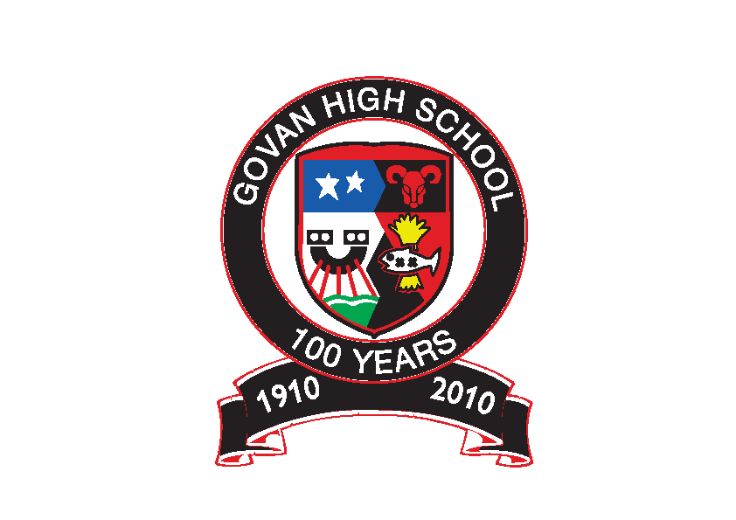Govan High School

Return to School – August 2020

Advice to Pupils & Parents

Dear Student and Parent/Carer

I hope that you and those around you are safe and well and that you got the opportunity to relax and enjoy the summer holidays.
Since the announcement of a full time return to school for all pupils across Scotland, we have been working hard behind the scenes to implement the advice given by the Scottish Government and Glasgow City Council. The return to school in August will not be a return to full normality as following the advice given, we have put measures in place to manage the risk of COVID-19.
This process has involved us keeping health and safety advice very much at the forefront of our plans to substantially reduce the risks to young people and ensure a safe return to school for all. What is crucial is that all young people adhere to the changes that we have made to ensure the safety of all young people and staff within the building.
This document takes you through what the return to school in August will look like. We hope that you find this advice useful and reassuring.

Yours faithfully

Mrs Belford
Headteacher

Health and Safety
Health and Safety is first and foremost as we return to school.

Risk Assessments
We have carried out risk assessments for the full time return of staff and young people to Govan High School in August. Some young people due to health or social and emotional reasons will need to have their own risk assessment specific to them. If this is the case then Pastoral Care or the Year Head will be in touch with individual families to discuss, prior to starting in August.
These risk assessments have taken into account the essential public health measures of;
- enhanced hygiene and cleaning arrangements;
- minimising contact with others (groupings, maintaining distancing for young people in secondary schools and physical distancing for adults);
- wearing appropriate personal protective equipment (PPE) where necessary;
- a requirement that people who are ill stay at home; and
- active engagement with Test and Protect.

School Day
All young people will now return to school on a full time timetable. There will be staggered start and finish times which are as follows:
S1 and S2 9.20am start and finish at 3.20pm Tue/Wed/Thu and 2.30 on a Mon/Fri
S3 and S4 9.05am start and finish at 3.30pm Tue/Wed/Thu and 2.40om on a Mon/Fri
S5 and S6 8.50am start and finish at 3.40pm on Tue/Wed/Thu and 2.50pm on Mon/Fri
Young people should not come into school before their designated time.
Whilst social distancing is no longer a requirement for young people in school, staff have set up their classrooms to allow for maximum distancing. When young people come into class they will be assigned their own desk and they must follow the teachers instructions re movement around the classroom/workspace.

Personal Hygiene

All young people must ensure:

- frequent washing/sanitising of hands for 20 seconds and drying thoroughly, and always when entering/leaving the building, before/after eating and after using the toilet;
- avoid touching their faces including mouth, eyes and nose; and
- using a tissue or elbow to cough or sneeze, and use bins that are emptied regularly for tissue waste.
Hand sanitiser will be available as young people enter the building, tissues will be available in all classrooms and teachers will communicate these key messages frequently to young people.

Physical Distancing
The Scottish Government has now advised that physical distancing is no longer a requirement for young people whilst in school. However young people in the Senior Phase should maintain safe distance from each other where this is possible. Young people will be encouraged not to crowd together and to keep a safe distance apart, in particular those young people in the senior phase.
Physical distancing of 2m still applies to al all adults in the building and between adults and young people. So young people must ensure they keep a safe 2m distance from staff whilst in the building.
A one way system has been put in place to help reduce movement and potential contact and this must be followed at all times.
Classrooms windows and doors will be open to allow for increased ventilation. There will be no large gatherings of young people, such as year group or whole school assemblies.

PPE
There is no requirement for pupils or staff to wear PPE equipment, including face masks. The only time a member of staff will wear a face mask is if they are unable to safely distance for more than 15 minutes. They may also wear PPE if they need to treat a young person for first aid or if a young person is displaying COVID-19 symptoms.
Although there is no requirement to wear a facemask, if a young person wishes to wear a facemask then they can do so.

Resources
The resources used in each class will be limited to minimise cross contact. All resources will be wiped clean after use. Disinfectant wipes will be available to allow this to happen. Young people must take responsibility to do this.
Young people should bring their own pen/ pencil. If they do not have one, they will be given one by their teacher and they should keep this. Young people will be allowed to take books and other resources home and avoid unnecessary sharing of resources.

Uniform & School Bag
School clothing should be washed as normal. The uniform from August will be black trousers/skirt and a white shirt, with black jumper or cardigan. For this reason, until restrictions are lifted, young people should not wear ties to school. Young people can bring a school bag to school but only carrying essential items. Young people should keep their bags on the floor and not on the desks/worktops.

Break and lunch times
These will be staggered to minimise contact with larger groups. Free school meals will be provided for those in receipt of this. Young people will also have the option to buy food in the fuel zone at break and lunchtime.
All young people are encouraged to stay in school over break and lunchtime and those who are not in receipt of a free school lunch or purchasing lunch in the fuel zone, should bring a packed lunch with them. An area of the school will be allocated for packed lunch provision.
If a young person leaves school at lunchtime, they should follow the rules in place for wider society, for example wearing a face covering when entering a shop. . If they do leave then they will not have access to the building until the end of lunchtime and must ensure that they wash their hands/sanitise on their return.

For S2, S4 and S5/6 – Break time will be 10.30-10.45 and lunch from 12.20-1ppm
For S1 and S3 - Break time will be 11.20-11.35am and lunch from 12.40-1.15pm

Extra-Curricular Activities
There will be no clubs, supported study or parents nights initially. This will be revised and updated as advice becomes available, until then supported study will be offered online by teachers.
Physical Education
Since the announcement of school closures due to COVID-19, the PE department have been planning a new curriculum in line with government and local authority guidelines. This guidance has changed since the announcement of a fulltime return to school and the relaxing of social distancing in school. The PE Department will continue to follow the most up-to-date guidance and will continue to explore activities that can be delivered outside, such as athletics, cross country running, fitness, orienteering, skill based performance training and cycling. The safety of our young people will be our main priority, therefore new procedures will be put in place when arriving and leaving the department.

Parent Contact with the School
We value our relationships with parents/carers however current advice is that parents/carers should not enter the school building unless required. For this reason we ask that you do not attend the school for any reason, unless you have a pre-arranged appointment.
If you need to speak to us urgently then please do not attend the school, but phone the school office on 01415820090 and if we cannot resolve the issue over the phone we will arrange a meeting time to bring you into the building safely.

Staying Vigilant and Responding to COVID-19 Symptoms
Whilst we are taking every precaution that we can to ensure a safe return to school for all, we all have a responsibility to stay vigilant of the symptoms of COVID 19.
The most common symptoms are:
- new continuous cough
- fever/high temperature
- loss of, or change in, sense of smell or taste
It is essential that young people do not attend school if symptomatic, but instead self-isolate (along with their household) and follow guidance on NHS Inform and from Test and Protect. https://www.nhsinform.scot/

It is also essential that the school is made aware of any young person/family where there is a likely or confirmed case of COVID.

If a young person shows COVID-19 symptoms whist in school they should let a member of staff know immediately. Staff First Responders have been identified and they will arrange for the young person to be isolated until parents/carers are contacted and the young person can be sent home. NHS Inform and from Test and Protect procedures should then be followed.
If there is an outbreak at the school then we will inform the local Health Protection Team (HPT) who will assess what action is needed. We will then work with the HPT to manage the outbreak.

Supporting our Young People Back to School

We are very aware that this has been a very abnormal time for young people and that they may have many anxieties about returning to school and about the impact that part time learning will have. We will do our utmost to support our young people as they return to school in August.
Young people will be offered a variety of supports by pastoral care and pupil support to help ease them back in to school life. The mental health and well-being of our young people is vital.
Health & Wellbeing when young people return to school will focus on resilience, helping them to understand the pandemic and feel comfortable asking questions. We are also developing questionnaires for young people around the return to school, asking what would make them feel safe and happy in school.
When young people return to school, they will have a 1-2-1 interview with either their Pastoral Care teacher or mentor to discuss any concerns that they may have and to look at any additional support that they might need. We will also work with other agencies, e.g. our counsellor, Quarriers, Lifelink, to tailor any support that young people might need.

Careers Support Next Session
The Next Steps Team at Govan High School’s aim is to help young people realise their career aspirations. We will continue to offer careers support and guidance to our young people, especially to pupils in the Senior Phase.
How will we continue to give career support to young people?
- All pupils in S5 and S6 have a timetabled ‘Pathways’ class. During this class, young people will discuss and finalise their career plans, create a personal statement, create a CV, apply for University/College/Modern Apprenticeship/Training.

- All new S6 pupils have been allocated a member of staff from the Next Steps Team who has been keeping in touch during lockdown to continue work on personal statements, virtual work placements, career programmes and they will continue to support them throughout the year in order to secure an appropriate positive destination.

- Due to the current situation, normal Work Experience Placements are unlikely to be available for the next while. However, there are a range of on-line and virtual opportunities available and Miss Arshad will continue to email information to young people and pass on information during Pathways classes.

- Over the years, we have built up many strong partnerships including: Marriott, DYW, Scottish Water, GHA, Focus West, MCR Pathways, Action for Children etc and they will continue to offer opportunities, albeit, online/virtual until we go back to our normal working pattern.

- Over the past few months, the Next Steps Team have continued to support our current leavers into destinations. Sheena, our Careers Advisor and Scott Smith, our Rangers Charity Hub Officer will continue to contact our leavers over the summer to offer support.

- Sheena will offer 1:1 coaching guidance by phone/online for all senior phase pupils throughout the year.

SDS Careers Contact Information
- Enhanced Helpline available for pupils and parents 0800 917 8000

