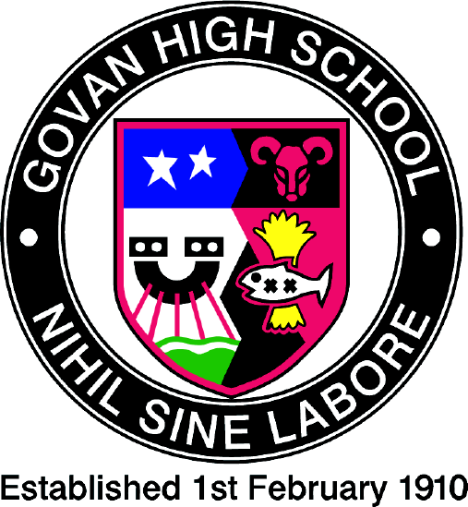

Govan High School

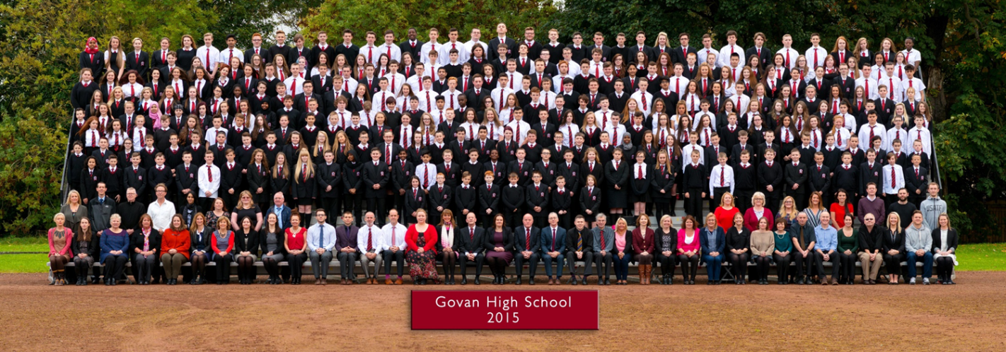

Prospectus 2020 - 2021

School Vision, Values and Aims
Vision: To create a caring, inclusive and happy learning community where all of our young people are inspired to achieve their full potential.

Values: Respect Responsibility Perseverance Excellence

Aims:
- To develop responsible citizens by fostering a positive, welcoming ethos in the school, with good working relationships and a sense of belonging
- To develop effective contributors by promoting active partnerships between staff, pupils, parents and the wider school community
- To develop successful learners by delivering a curriculum that is relevant, challenging and appropriate to meet the needs of all pupils
- To create confident individuals equipped with the qualifications and skills needed to secure a positive destination beyond school

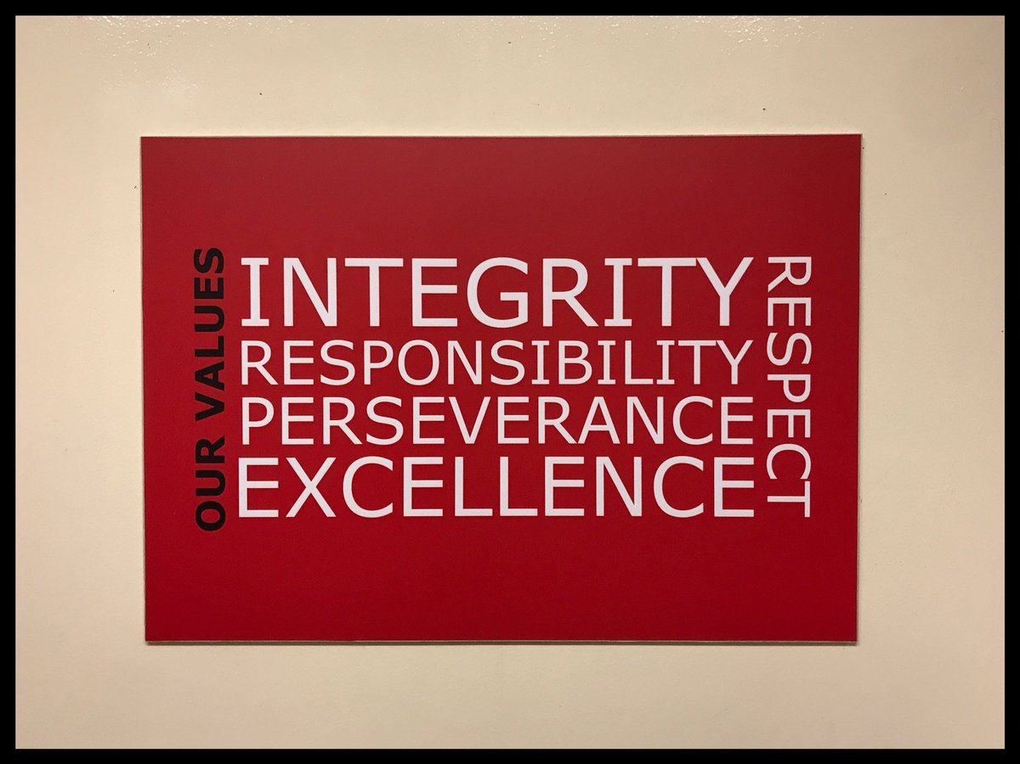

The normal school day
- Start 8.50am
- 6 or 7 Periods: 50mins
- Interval: 10.30 -10.45am
- Lunch: 12.25 – 1.10pm
- Close 2.50pm Monday & Friday and 3.40pm Tuesday, Wednesday & Thursday
Attendance and Timekeeping
Good attendance and time keeping leads to higher pupil attainment. One week’s absence means 3% of learning lost. Parents, pupils and teachers should all work together to achieve better attendance and higher achievement.
Pupils will receive Merits every week if they have 100% attendance. These Merits are awarded, not only for attendance, but for full uniform, behaviour and following the school values. Pupils with 25+ Merits will receive certificates, iRESPECT badges for following the school code, and can participate in extracurricular trips.

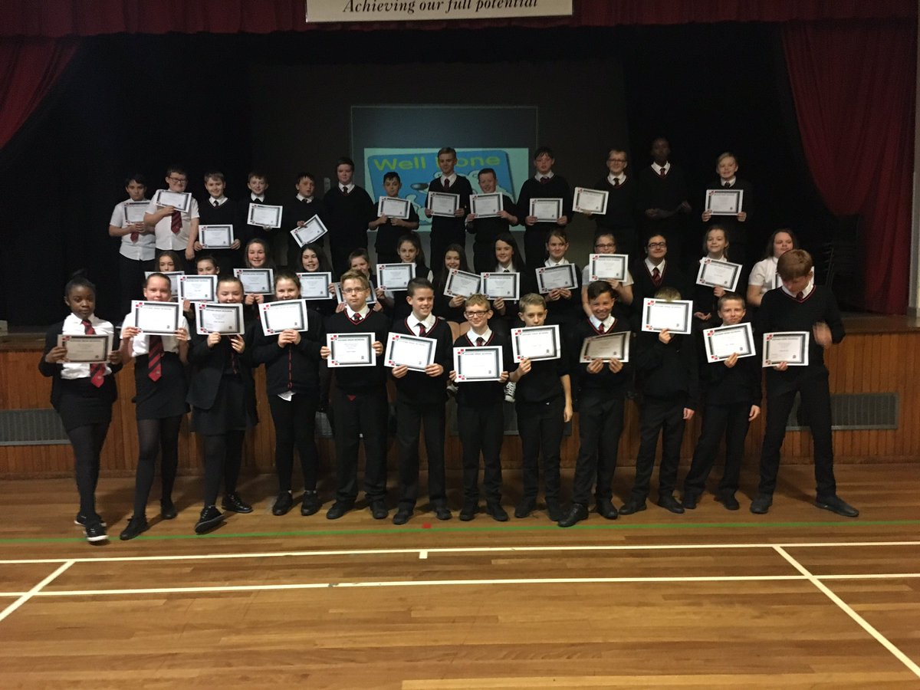
Pupil Support

Young people are supported in school by a number of different specialist members of staff.

Pastoral Care Teachers – we currently have three Pastoral Care teachers within the school who oversee the health and wellbeing of all young people. If you have any concerns or any information that you feel that is important that we know then you should contact this member of staff in the first instance.

DHT Pupil Support – We also have a Depute Head Teacher who is responsible for overseeing and co-coordinating Pupil Support and health and wellbeing across the school. He is involved in ensuring that our most vulnerable young people receive the support that they need and also manages Child Protection within the school.

Heads of Stage – We have two further Depute Head Teachers who oversee assigned year groups. One who oversees all pupils in the Broad General Education (S1-S3) and one who oversees all pupils within the Senior Phase. These members of staff are responsible for the monitoring and tracking of pupil progress as well as overseeing the options process and pupil behaviour.

Learning Support – We have a learning support department within the school which is led by our Principal Teacher of Learning Support, a Learning Support teacher and 2 pupil support assistants and outside agencies to ensure that pupil learning needs are met.

Home Support Worker – provides support to ensure pupils keep high levels of attendance

Management Structure
Head Teacher Mrs Nancy Belford
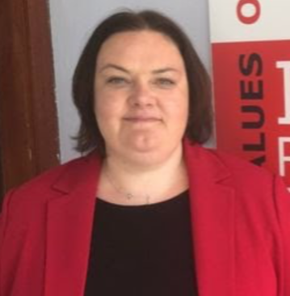
Depute Pupil Support & S1 Ms Paula Wlosinski
Depute S2 & S3 Mr Michael McCarron
Depute Senior Phase Mrs Sonja Kerr
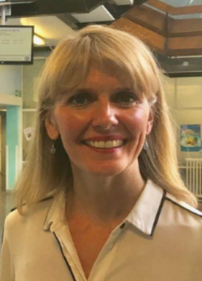

Depute LCR Mr Kevin Sweeney

Pastoral Care Mrs Bernie Templeman, Ms Jen McMillan, Ms Lucy McNaught,
Home Support Worker Ms Elaine Lennox

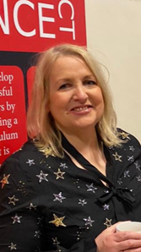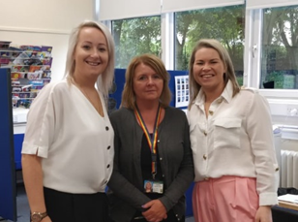

Learning Support Ms Julie Ainslie

Primary Transition
Primary to Secondary Transition
Govan High works closely with our cluster primaries. The quality partnership with our cluster primaries is central to our practice of ensuring a smooth move from primary to secondary, in terms of the curriculum and learning experiences, and also in continuing to build pupils' confidence.
Parents of P7 pupils were invited to our Open Evening in October for the opportunity to meet school staff and experience our showcase of learning and teaching, as well as to receive information about our school and to ask any questions. Throughout Primary 5 & 6 there are opportunities for the young pupils to visit Govan High. Once pupils reach Primary 7, there are many more opportunities. In September and October there is a 6 week programme for P7 pupils to visit our school every week and take part in many activities. As part of our Liaison Programme with Pirie Park and Riverside Primaries we have hosted a 6 week programme to give young people the opportunity to attend Govan High School and experience learning in a number of subject areas. These visits allowed your child to find out more about the school and to become familiar with the building as well as meet many of staff and young people within the school. We hope that these visits allow those potentially transferring to Govan High in August 2020 to start to build positive relationships and confidence in this major step in their school journey. Historically, during the summer term, all P7s are invited to participate in a three day, high-quality experience at Govan High School. However, with the current lockdown due to COVID19, it is unlikely that this will be possible in June 2020. Instead, we will offer a virtual transition over the 9th- 11th June when we will send out video clips about the school and taster lessons from a number of different subject areas. When it is safe to do so we will offer some form of transition visits to the school so that your young person has a chance to attend the school and meet their teachers prior to starting their S1 year. Once when we know more and have a clearer timescale, we will be in contact with further details.

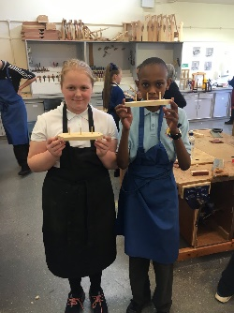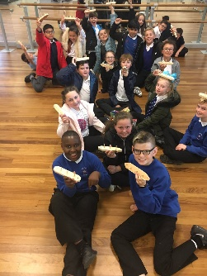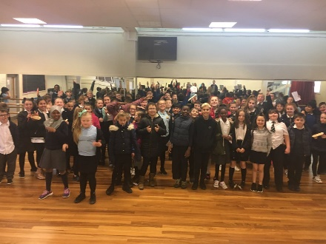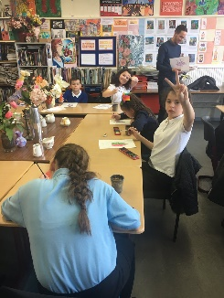

Uniform
It is the expectation that each young person will wear the full school uniform each day that they attend school. This sets the tone for the day and we encourage each young person to dress for success. The school uniform is as follows:
- Black trousers or skirt
- White shirt
- School tie
- Black footwear
- Black cardigan or jumper
- School blazer
- Black outer jacket when required
The uniform can be purchased at https://www.border-embroideries.co.uk/
Please note all young people must come equipped for school and carry a school bag. This includes a pen/pencil, materials needed for their subject areas and PE kit on the days required.
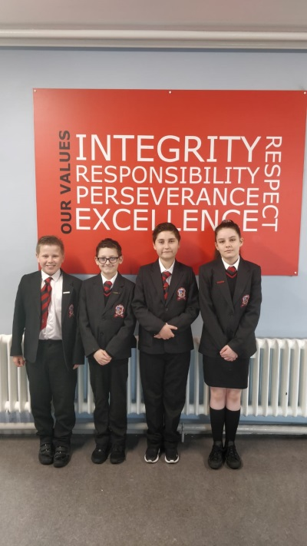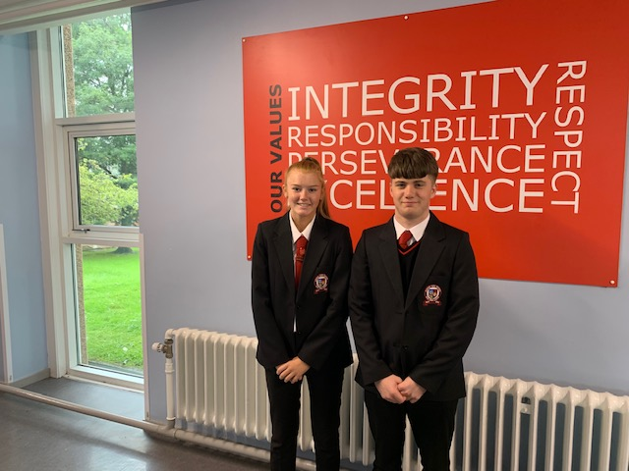

Fuel Zone
A variety of snacks at interval and hot and cold food at lunchtime are sold in our Fuel Zone. The cost of a school lunch is £1.90.

Curriculum for Excellence
Curriculum for Excellence states that every young person should:
- experience a traditionally broad Scottish curriculum that develops skills for learning, skills for life and skills for work, with a sustained focus on literacy and numeracy, that encourages an active, healthy and environmentally sustainable lifestyle and that builds an appreciation of Scotland and its place in the world
- benefit from learning and teaching that strikes a balance between equipping them with the skills for passing exams and skills for learning, skills for life and skills for work; there should be no need for groups of young people to take examinations before the end of S3
- have their learning and achievements recognised by an assessment system that supports the curriculum rather than leads it and ensures that their transition into qualifications is smooth
- produce a Learner Profile, supported by a member of staff who knows them well, which allows them to reflect upon their learning and give a reliable account of their progress and achievements

With this in mind, in Govan High School we wish to:
- Develop the curricular structure in place to meet the demands of Curriculum for Excellence
- Offer pupils in S1 to S3 a true Broad General Education across the curricular modes
- Offer pupils as they move into the senior phase personalisation and choice to meet a wide range of needs
- Increase the focus on attainment in academic subjects
- Continue to meet the needs of those who leave school and go on into apprenticeships and the world of work
- Retain pupil ability to achieve across a number of subject areas
- Create a parity of esteem between vocational and academic
- Put in place a curriculum that meets the needs of all learners
- Ensure that there remains a key adult who knows each pupil well and can have conversations with the young person to support their progress
- Build time into the curriculum for wider achievement
- Ensure that young people continue to develop skills for learning, skills for life and skills for work as outlined in Building the Curriculum 4

The Broad General Education in S1 to S3
Pupils will experience breadth within the S1 to S3 curriculum and this is achieved through learning across all the experiences and outcomes in the eight curriculum areas (Expressive Arts, Health and Wellbeing, Languages, Mathematics, Religious and Moral Education, Sciences, Social Sciences and Technologies).

Wider Achievement and Raising Attainment
Time has been built into the curriculum for Wider Achievement and Raising Attianment. This offers pupils a wide range of additional opportunities to achieve and also offers increased personalisation and choice.

Learner Profile
All young people will also compile a Learner Profile through their Raising Attainment classes. This will allow pupils to reflect upon their achievements across all curriculum areas, including literacy, numeracy and health and well-being. The profile will also include learning experiences out with the classroom in extra-curricular activities, as well as wider achievements outside of school. This will help develop in learners’ personal ownership of their own learning and achievements and promote their understanding of their own skill development. The Raising Attainment period will be used to ensure that pupils receive the Universal Support that they are entitled to and that have a key adult who knows them well and can have reflective conversations with them regarding their learning, attainment and wider achievements.

How do we assess your child?
The S1-S3 curriculum is based upon Experiences and Outcomes. Progress in your young person’s learning is assessed using experience they are involved in and outcome they achieve. This could happen in the classroom or on a study visit. In all subject areas your young person will also be assessed on their development of numeracy, literacy and health and well-being.
Your child will be assessed as part of their on-going daily learning and using a variety of methods e.g. giving a presentation, researching a topic, written test, or even a teamwork photo.

The Senior Phase:
Building the Curriculum 3 outlines that every young person is entitled to experience a Senior Phase which:
- Provides specialisation, depth and rigour
- Prepares them well for achieving qualifications to the highest level of which they are capable
- Continues to develop skills for learning, skills for life and skills for work
- Continues to provide a range of activities which develop the four capacities
- Supports them to achieve a positive and sustained destination.

How do we monitor and track young people’s progress?
To make sure that each young person can see how they are progressing they will be regularly tracked across all of their subject areas and teachers will follow this up with conversations with young people about their progress. Pupils will receive a copy of these tracking reports and will use them to set targets during Raising Attainment periods where again they will have a conversation with their teacher about their progress across their learning, in their wider achievements and about the targets that they have set for improvement. These reports will be sent home three times throughout the course of the session. Details of when can be found on the school website.
As part of our assessment procedures, all pupils take part in ‘learner conversations’ with their teachers, Faculty Heads and Deputes/Head Teacher. The learner conversations help pupils to set personal targets and allow teachers to check pupils’ progress to make sure that each child is achieving her/his potential.

Reports & Parent’s Evenings
In addition to the tracking reports issued three times each session you will also receive a full written report on your young person’s progress and next steps in each of their subject areas. This will be followed up with a parent’s evening which will give you the opportunity to speak to each of your young person’s teachers about their progress and any concerns that you may have. Details of the dates of reports and parents evenings will be added to the school website prior to the start of sessions 2020/2021.
It is important that you attend parent’s nights.
Parent Voice
The membership of the Parent Voice comprises of a majority of parents, along with co-opted members chosen to represent the school and the community. Parent Voice has a variety of duties and functions, including communication with parents; monitoring school areas such as budget, premises and staffing; and taking part in the appointment of senior staff in the school.
The Chair of the council is elected annually and a parent can serve on the council for up to four years before coming up for re-election. Meetings are held during the school day and once a term.
All parents are encouraged to join the Parent Voice and are welcome to come along to meetings.

