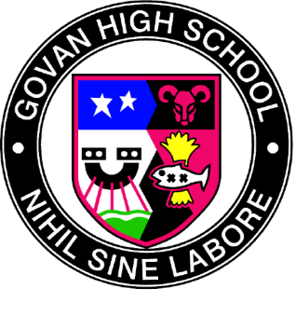
Govan High School

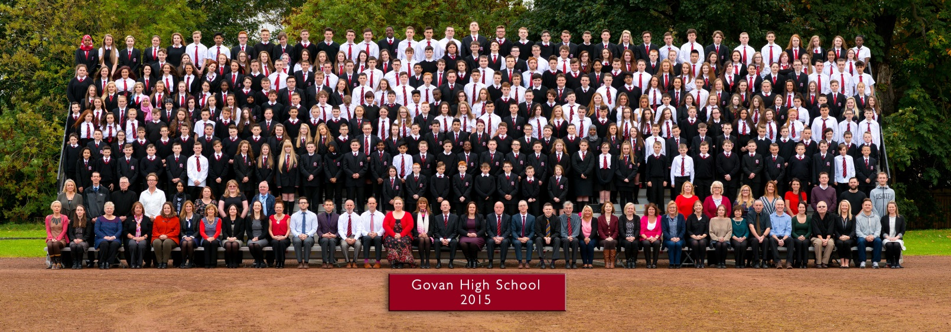

Handbook
2020-21
Last updated 12th September 2020

Contents
Section 1 – The School
Introduction
Visions, Values & Aims
General Information
Enrolment
School Curriculum
Assessment & External Qualifications
Tracking, Reporting & Parents’ Evenings
Homework
Extra-Curricular Activities
Citizenship
Subject Information link
Charity Events
International Education

Section 2 – General Information
Pupil Support
Pastoral Care
GIRFEC and the Named Person
Inclusion Base
Child Protection
Equal Opportunities
Health & Safety and Emergencies
Attendance
Medical Information
Promoting Positive Behaviour
School Uniform
Clothing Grants and School Meals
Education Maintenance Allowance
Transport
Parent Council
Communication
GHS School Archive
Language Communication Resource (LCR)
Nurture
Partnerships
The School Year 2020-21
Freedom of Information Act
Complaints

Section 1
The School

Introduction by the Head Teacher
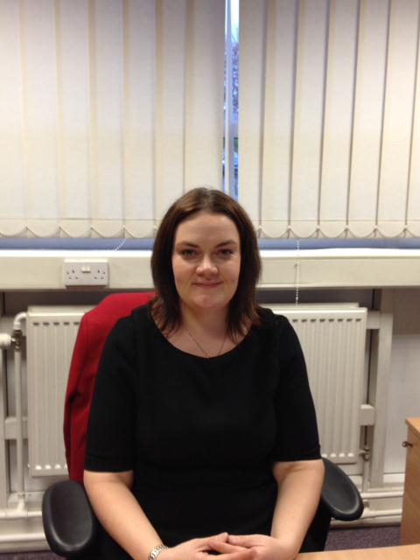
It gives me great pleasure to present to you the Govan High
School Handbook. I hope that you will find this handbook useful
and informative and that it gives you a flavour of what the school
is about.

In Govan High School we strive to create a caring, inclusive and
happy learning environment where every young person is
inspired to achieve their full potential. Our school motto
‘Nihil Sine Labore’ , translated as ‘nothing without work’, is the
essence of what Govan High School is all about – working hard to
achieve the best that you can. There is a dedicated team of staff
and partner agencies working within the school to ensure that
each young person has the opportunity to do just that.

Through our delivery of Curriculum for Excellence we ensure that pupils experience a broad general education which delivers breadth, depth and challenge in learning until the end of their third year. Pupils are then able to build on this as they move into the senior phase with a curriculum that offers progression, the opportunity for academic attainment to the highest level possible as well as opportunities for pupils to follow vocational programmes. No matter the pathway a young person opts for, we are able to support each of our learners on their journey towards a positive and sustained destination.

We aim to develop in all young people the skills and values needed to go on to be successful in life. Through a wealth of activities all young people are given the opportunity to build a portfolio of wider achievements, often gaining awards and accreditation for these. Our focus on skills across the curriculum also ensures that all young people gain the skills needed for learning, life and work.

Govan High School is a caring and inclusive community and we work hard to ensure that all pupils are safe, healthy and achieving. Through practising our values of respect, responsibility, integrity, perseverance and excellence we hope that every young person will leave school well prepared to go on and lead fulfilling and meaningful lives.

I hope that this handbook gives you a glimpse of life at Govan High School. We look forward to having you and your young person with us and hope that this will be the start of a strong partnership. Please do not hesitate to contact the school or check the school website if you need more information.

Nancy Belford
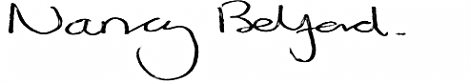
Head Teacher

Our Vision, Values and Aims

Vision
To create a caring, inclusive and happy learning community where all of our young people are inspired to achieve their full potential.
Values
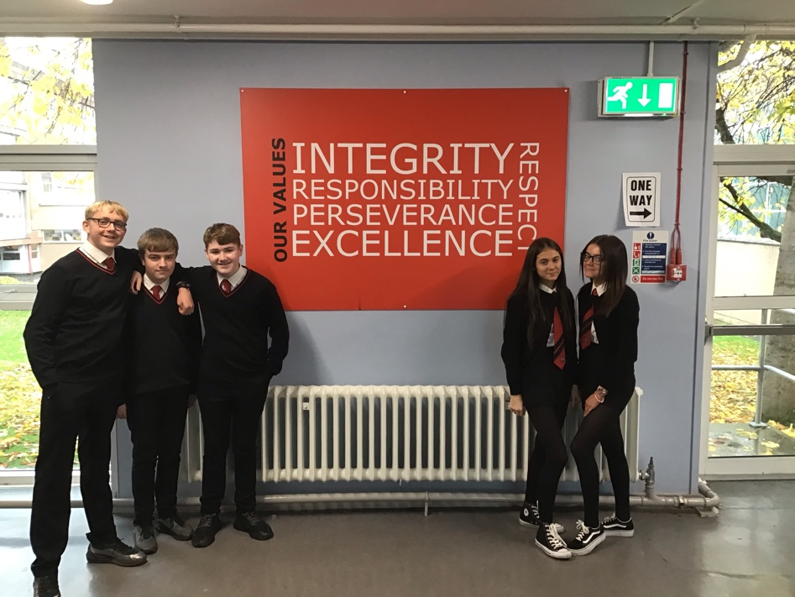
Integrity Respect Responsibility Perseverance Excellence

Aims
To develop responsible citizens by creating a positive & welcoming ethos in the school

To develop effective contributors by promoting partnerships between staff, pupils, parents and the wider school community

To develop successful learners by delivering a curriculum that is relevant, challenging and meets the needs of all pupils

To create confident individuals with the qualifications and skills needed to achieve a positive destination beyond school
Motto
‘Nihil Sine Labore’ translated as ‘nothing without work’

General Information
Govan High School
12 Ardnish Street
Govan
G51 4NB
Telephone Number: 0141 582 0090
Email: Headteacher@govanhigh.glasgow.sch.uk
Website: www.govanhigh.glasgow.sch.uk
History
Govan High School is a non-denominational, co-educational, comprehensive school that caters for pupils aged 12-18. The school can trace its history back to 1874, although the name Govan High dates from 1 February 1910. Govan High moved to its present site in 1969 when the present building was opened by Mr Anthony Hepper who was Chairman of Upper Clyde Shipbuilders at that time. The refurbished building was re-opened by Sir Alex Ferguson CBE on 12 September 2002. Sir Alex is a former pupil. The school celebrated its centenary year in 2010.

Roll
The roll for 2019-20 is 490 at the time of writing. The roll is made up of:-
S1 - 83
S2 - 109
S3 - 84
S4 - 90
S5/S6 - 124
The school has a co-located Language and Communication Resource (LCR) for children on the autistic spectrum, located on the top floor. It has capacity for 40 pupils. The Inclusion Base will be a new unit based within the school opening in August 2018. This unit will accommodate up to 12 young people from across the city with social, emotional needs. This unit will be staffed with 2 FTE and 3 SfL Assistants.
Accommodation
Most teachers presently have a room for their own exclusive use and almost all teaching areas have an interactive whiteboard and a projector. There are 5 computer suites; Art & Design, Home Economics, the Sciences and Technical Education all have special practical areas; Physical Education has 3 gymnasia and a swimming pool; the Pirie Park, adjacent to the school campus has areas for football, hockey and athletics. The school library also contains an ICT suite

Associated Primary Schools
Govan High School has 2 associated primaries, Pirie Park and Riverside.

Pirie Park Primary School Riverside Primary School
HT: Susan Clark (Acting) HT: Mrs Louise Brimelow
337 Langlands Road 635 Govan Road
Glasgow City Council Glasgow City Council
G51 4AW G51 2AQ
0141 445 5884 0141 445 2901

The School Day
Period 1 8.50 – 9.40
Period 2 9.40 – 10.30
Interval 10.30 – 10.45
Period 3 10.45 – 11.35
Period 4 11.35 – 12.25
Lunch 12.25 – 1.10
Period 5 1.10 – 2.00
Period 6 2.00 – 2.50
Period 7 2.50 – 3.40 (Tuesday, Wednesday and Thursday only)

Senior Management Team
Nancy Belford (Head Teacher)
Alexis Grant , DHT Senior Phase (Acting)
Paula Wlosinski, DHT S1 & Pupil Support
Michael McCarron, DHT S2 & S3
Vince McMahon, DHT, LCR & Inclusion Base

Principal Teachers

James Beattie, (Acting) Faculty Head, Citizenship
Angela Nugent - Faculty Head Home Ec, Art and Technologies
Gordon Fischer – Principal Teacher of English
Gillian Molloy – Principal Teacher of Mathematics
Neda Arshad – (Acting) Principal Teacher of Developing Govan’s Young Workforce
Stephen Ogston – Principal Teacher of the Inclusion Unit (Acting)
Julie Ainslie - Principal Teacher of Pupil Support
Simone Doherty – Principal Teacher Wider Achievement
Heather Oswald - Principal Teacher LCR
Jennifer Andrews - Principal Teacher of Music
G Reid - Principal Teacher Physical Education
C O’Connor - Principal Teacher Science

Principal Teachers of Pastoral Care
J McMillan – Ferguson House
Lucy McNaught – Bruce House
Bernadine Templeman – Ogilvie
Attendance officer – Elaine Lennox
Enrolment
The majority of pupils enrolling in Govan High School do so from our associated primary schools. Our associated Primary Schools are Pirie Park Primary and Riverside Primary School.

Primary/Secondary Transfer Arrangements
Steps are taken to try and ensure the transition from Primary to Secondary is as smooth and trouble free as possible:

- Regular meetings are held between the head teachers and deputes of both Govan High School and our associated primaries which allows us to discuss and plan our transition programme, the curriculum and share important information
- There is a transition programme for all pupils in Primary 7 in October/November where pupils attend one afternoon a week for 6 weeks in various subject areas. A parent information evening is held in the school at the end of this programme.
- A Deputy Head Teacher, members of the Pastoral Care team and members of the Pupil Support Department visit the associated primaries in April and May of each session to identify the particular needs of the new intake and to discuss with primary colleagues the progress of all pupils coming to Govan High.
- During June all primary 7 pupils intending to come to Govan are invited to attend the High School for a 3 day period. This gives them an opportunity to meet their new teachers and to familiarise themselves with their new surroundings.

We also welcome families from outwith our area. Families living out with the school catchment area are welcome to make a placing request to attend Govan High School. Prospective parents are welcome to visit the school and should contact the school office to arrange an appointment. Further information on how to make a placing request is available at: www.glasgow.gov.uk/index.aspx

SCHOOL CURRICULUM

A Curriculum for Excellence

Curriculum for Excellence is designed to achieve a transformation in education in Scotland by providing a coherent, more flexible and enriched curriculum from 3 to 18. The 3-18 curriculum aims to ensure that all children and young people in Scotland develop the attributes, knowledge and skills they will need to flourish in life, learning and work.

The knowledge, skills and attributes learners will develop will allow them to demonstrate four key capacities – to be successful learners, confident individuals, responsible citizens and effective contributors.

Curriculum for Excellence states that every young person should:
- experience a traditionally broad Scottish curriculum that develops skills for learning, skills for life and skills for work, with a sustained focus on literacy and numeracy, that encourages an active, healthy and environmentally sustainable lifestyle and that builds an appreciation of Scotland and its place in the world
- benefit from learning and teaching that strikes a balance between equipping them with the skills for passing exams and skills for learning, skills for life and skills for work
- have their learning and achievements recognised by an assessment system that supports the curriculum rather than leads it and ensures that their transition into qualifications is smooth
- produce a Learner Profile, supported by a member of staff who knows them well, which allows them to reflect upon their learning and give a reliable account of their progress and achievements

Stages of Learning within a Curriculum for Excellence
Level | Stage
Early | The pre-school years and P1, or later for some
First | To the end of P4, but earlier or later for some
Second | To the end of P7, but earlier or later for some
Third and Fourth | S1 to S3, but earlier for some. The fourth level broadly equates to Scottish Credit and Qualifications Framework level 4  The fourth level experiences and outcomes are intended to provide possibilities for choice and young people’s programmes will not include all of the fourth level outcomes
Senior Phase | S4 to S6, and college or other means of study

With this in mind, in Govan High School we aim to:
- Develop the curricular structure in place to meet the demands of Curriculum for Excellence
- Offer pupils in S1 to S3 a true Broad General Education across the curricular modes
- Offer pupils as they move into the senior phase personalisation and choice to meet a wide range of needs
- Maintain the focus on attainment in academic subjects
- Continue to meet the needs of those who leave school and go on into apprenticeships and the world of work
- Retain pupil ability to achieve across a number of subject areas
- Create a parity of esteem between vocational and academic
- Put in place a curriculum that meets the needs of all learners
- Ensure that there remains a key adult who knows each pupil well and can have conversations with the young person to support their progress
- Build time into the curriculum for wider achievement
- Ensure that young people develop skills for learning, skills for life and skills for work

Broad General Education S1 to S3
Breadth within S1-S3 (third and fourth curriculum level) is achieved through learning across all the experiences and outcomes in the eight curriculum areas (Expressive Arts, Health and Wellbeing, Languages, Mathematics, Religious and Moral Education, Sciences, Social Sciences and Technologies) so far as this is consistent with young people's needs and prior achievements.
Personalisation and an element of choice will be provided in S3, whilst continuing to meet the requirement of curricular breadth and depth within the broad general education. In S3 young people will continue to study within the eight curricular areas but there is a degree of personalisation and choice. Subjects studied include: English, Mathematics, Health & Well-being, Modern Languages (French & Spanish), Geography, History, Modern Studies, ICT, Physical Education, Home Economics, RE, Technical Education, Science (including Biology, Chemistry and Physics), Art and Music.
Wider Achievement time has been built into the curriculum, this will sometimes involve interdisciplinary learning. This offers pupils a wide range of additional opportunities to achieve and also offers increased personalisation and choice. For example, Govan High School is currently the only school in the country to offer the Earl of Wessex course which leads to the Duke of Edinburgh Award in Senior Phase. Both programmes are supported by the Govan Weavers.
Learner Profile
All young people will also compile a Learner Profile as they complete their Broad General Education. The profile is completed during Raising Attainment classes, immediately after the young people receive the feedback from their most recent round of tracking and monitoring. This will allow pupils to reflect upon their achievements across all curriculum areas, including literacy, numeracy and health and well-being. The profile also details learning experiences out with the classroom in extra-curricular activities, as well as wider achievements outside of school. This will help develop in learners’ personal ownership of their own learning and achievements and promote their understanding of their own skill development.
The SFA programme is offered to pupils S1-S3 within the BGE. The programme is designed to mould better citizens and develop social and academic abilities through the vehicle of football.
- Football is used as a tool to motivate pupils to enhance social skills, communication and behaviour.
- The programme is funded by the Scottish Government, cash back for the community’s fund.
- The school works in partnership with the Scottish Football Association and Rangers Football Club.
- It is a two year programme
- Pupils get accreditation and work through dynamic youth awards.
- Pupils work through a classroom programme which has many IDL links

The Senior Phase
Every young person is entitled to experience a Senior Phase which:
- Provides specialisation, depth and rigour
- Prepares them well for achieving qualifications to the highest level of which they are capable
- Continues to develop skills for learning, skills for life and skills for work
- Continues to provide a range of activities which develop the four capacities
- Supports them to achieve a positive and sustained destination
In Govan High School as pupils’ progress into the senior phase they will carry out further personalisation and choice. In S4 pupils will opt to study 7 subjects (including English and Maths). Subjects in S4 will be delivered at National 4 and National 5 level for the majority.
In S5 pupils will carry out further personalisation and choice, selecting 5 subject areas which will be studied over 6 periods per week. Vocational and wider achievement opportunities have also been written into the option structure to give pupils increased flexibility, specialisation and choice.
In addition pupils in senior phase will experience a weekly double period of Wider Achievement where they can choose from a menu of sports activities, outdoor learning, Cadets, Duke of Edinburgh Award and others. PSE and RE are addressed through a bespoke programme of workshops and assemblies with much of the content being delivered by visiting speakers and specialists.
Developing Scotland’s Young Workforce
In Govan High School a considerable amount of time and resources has been devoted to meeting the demands laid out by the Sir Ian Wood Report and the Scottish Government’s response – Developing Scotland’s Young Workforce. In Govan High we have been extremely creative in our response, to ensure that pupils develop the skills for learning, life and work and that our young people have the opportunity to follow flexible pathways in the senior phase which will lead to positive destinations.
Govan High School has spent a considerable amount of time revising the Future Skills programme which was previously in place. Six skills sets have been identified and pupils are exposed to these skills from S1 onwards. Skills and skills development are highlighted each period across curricular areas and young people quickly become aware of what skills they are using and developing. As part of our Raising Attainment (BGE only) and Pathways (Senior phase) classes we ensure that young people are self-evaluating their skills development in addition to the formal assessment of skills that takes place within curricular assessments. This ensures that pupils are able to reflect on their skills set, identifying their strengths and areas for improvement which they can talk about in CVs and application forms or attend interviews.

Employability Programme
There is a focus on employment and careers from S1 onwards. Starting in S1, pupils are engaged in a programme that focuses on the world of work, enterprise and career education and this is built upon as they progress through the stages of their school career. This involves looking at different careers and workplaces, with input from different employers at different stages. Pupils take part in different enterprising activities as they progress through their school career, many of which are delivered by our partner employers and industries. In the senior phase one of the options open to pupils is the National Progression Award: Enterprise and Employability.
Work Experience
Almost all pupils will undertake at least one week of work experience at some point during their senior phase. The purpose of this is to allow young people the opportunity to experience the world of work and to perhaps try working in the field they see as their future career. For some young people they may opt to carry out work experience on a weekly basis as part of their timetable.

Career Education
Again, this starts in S1 and is built upon as pupils’ progress through school. Careers information is delivered to pupils by our partners Skills Development Scotland and as pupil progress into their final year in school they can seek one to one support to help them progress into the right career for them. In addition to this pupils complete CVs, personal statements and are supported through applying for jobs and apprenticeships. They also receive interview advice and mock interviews as required. We also host careers information events at our senior parents’ nights where numerous colleges, universities and employers attend to speak to pupils and their parents about future careers.

Pathways Partnerships
Govan High School has a wealth of partnerships which we use to support our pathways for young people in the senior phase. These include:
- Clyde College where pupils can opt to follow vocational subjects
- Foundation Apprenticeships
- Morris and Spottiswood and Luddon Construction who help finance and support our pre-apprenticeship programme
- Associated primaries and nurseries where work experience can also be arranged
- DYF, a tax law firm that offers a 6 week employability programme and work experience for young people in S4
- The Marriot Hotel offer a wealth of work experience opportunities and taster sessions in the hospitality industry
In addition to this, our successful partnerships have led to a number of our pupils securing positive destinations via apprenticeship programmes as a result of school links.

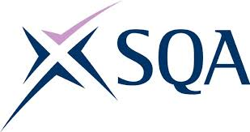
Assessment

Assessment is an extremely important part of the learning and teaching process. The purposes and methods of assessment have changed considerably and the one off examination is no longer the only means of assessment. Continuous assessment is more accurate, helpful to pupils and fairer. Formative assessment is also used to encourage pupils to think about what they have learned and how to get better at learning. As a result, pupils will be assessed using a variety of techniques throughout the course of the session.
External Examinations & Presentation Policy
Pupils will be presented for National Qualifications normally from the end of their fourth year. Study for these national qualifications will generally begin in S4, building on prior learning as appropriate. Pupils can gain qualifications from the Scottish Qualification Authority (SQA) at the following level:
National 2 to 4 – consists entirely of internal assessment of unit-based coursework. The qualifications are ungraded and if successful pupils receive a pass in this qualification
National 5 – consists of a final external exam. These qualifications are graded A to D
Higher - consists of a final external exam. These qualifications are graded A to D
Advanced Higher - consists of both regular internal coursework assessment and a final external exam. These qualifications are graded A to C
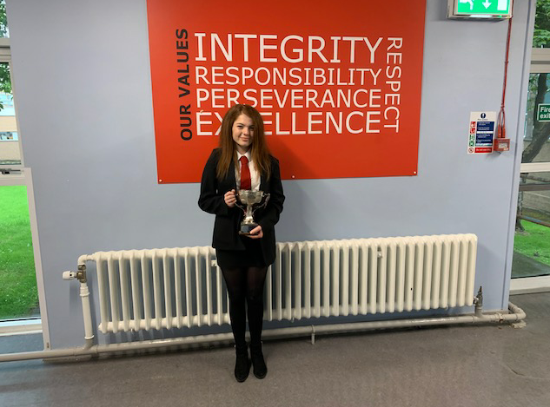
The level of presentation at National 2 to Higher across S4 to S6 is decided in partnership with the pupil, parent and school, having given due consideration to a pupil’s previous performance within that subject area.

Our 2019 Dux – Rachel Thomson, Achieving 5 x A1 at Higher Level

Tracking & Reporting
Pupil progress is rigorously tracked throughout the course of the session and interventions put in place as and when required. Parents will receive three tracking reports each session which give a quick and easy to read overview of the working level and progress of their young person in each curricular area. In addition to this they will also receive a full written report once per session which will outline the progress and next steps for improvement.

Parents’ Evenings
Parents’ Evenings are held annually for all year groups. All parents/carers are encouraged to come along to the parents’ evening and subject staff and Pastoral Care staff are on hand to advise parents on their child’s progress and behaviour. If however a pupil has a particular difficulty, the school will contact parents as soon as possible to discuss the problem.

Any parent wishing a more detailed discussion about their child’s academic progress or behaviour in school is free at any time to contact either the relevant member of the pastoral care staff of the appropriate deputy head teacher to arrange a meeting.

Homework
Homework is one of the main ways in which pupil achievement can be raised. Within this context, our aim is to create an environment in which learning is valued to such an extent that consolidation of class work is seen as a natural and important part of the learning process. In providing homework, teachers support pupils’ learning beyond the classroom – as opposed to imposing upon their leisure time - and, hopefully, parents would be encouraged to become active partners in this process.
Our aim is to instil the benefits of doing homework at an early age in all pupils, ensuring that independent home study becomes routine. The aim of our homework policy is to:
* enable pupils to understand that independent learning is vital to achieving success
* give every pupil the opportunity to fulfil their potential
* instil in all pupils the importance of life-long learning
* provide training for students in planning and organising time
* promote a responsibility for learning within each pupil
Our current homework policy is being reviewed and will appear here once it has been agreed and can be viewed by clicking on the hyperlink. The policy will also be available through our school website.

Extra- Curricular Activities: There is a wide range of opportunities for all young people to become involved in activities which widen achievement: during and after the school day pupils can participate in Drama and Dance classes; sports teams and outdoor activities; various musical activities and clubs; and the school offers the Earl of Wessex and Duke of Edinburgh Award Schemes as a course which spans both the curriculum and extra-curricular activities.
Citizenship
The school Eco clubs meets regularly to discuss what they can do to improve the environment in and around Govan High School. Recently they worked with the RSPB to create and area in the garden to encourage house sparrows to nest there. They also spend time in the local community carrying out litter picks to help keep our environment and the surrounding community tidy.
Subject Information
Detailed information on subject content, courses, assessment and SQA presentation can be found on the school website or by clicking on this link:
Subject Information 2018/2019
Charity Events
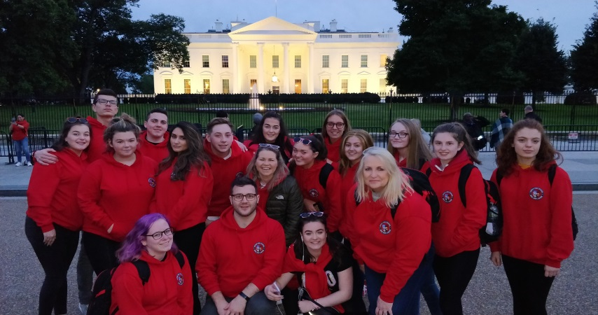
The school and the young people within give generously to local and national charities through a number of events held throughout the course of the session. Non-uniform days are held to raise funds for charities such as Children in Need, Yorkhill Sick Kids, MacMillan Cancer Support and Breast Cancer Awareness. Young people also collect items to make up Christmas hampers for the local women’s shelter.
International Education
Govan High has had a very successful partnership with Mount Gambier High School in Australia for many years now and we have an exchange programme in place which gives our young people the opportunity to take part in an international study visit to Australia every second year. In addition to this, our regular international visits include the annual football trip to Spain, the Spanish language and culture trip and the Holocaust Education Fund excursion to Auschwitz. Last session pupils studying national certificate courses in History took part in the Battlefields study visit to Belgium and France and young people learning Modern Studies visited the USA.

Section 2

General
Information
Pupil Support
In Govan High School we strive to ensure that each of our young people achieves their full potential. Our Pupil Support Team plays a major role in ensuring that this aim is fulfilled. Our Pupil Support Team consists of Pastoral Care and Learning Support and is overseen by Depute Head Teacher P Wlosinski.
Pastoral Care
The learning needs of pupils are more often met when pupils, teachers and parents work together. It is important that the school is made aware of any issues in a young person’s life that could impact on their progress, behaviour or even attendance in school. Likewise, the school will contact parents to make them aware of any concerns that may arise. Often parents will be invited into the school to discuss issues arising with their young person’s Pastoral Care Teacher
The Pastoral Care teachers within Govan High School have a responsibility to help and support all pupils in their journey through school. In Govan High we operate a house system. There are three Pastoral Care teachers who oversee pupils from S1 to S6in each of the houses; Ogilvy, Bruce and Ferguson. This allows them to use their expertise to help guide pupils throughout their Govan High journey and to best support them at times of transition.
It is important that parents feel free to contact the Pastoral Care teacher regarding their young person. This can be done by contacting the school office. Parents should see the Pastoral Care staff as a source of support and information.
Govan High Pastoral care staff also work with a number of outside agencies to ensure all pupils achieve their full potential. These include the Social Work Department, Psychological Services, Youth Services, CAMHS and the NHS.
Depute Heads in Charge of Year Groups for Session 2019-20
Depute Head Teachers
S1 Paula Wlosinski
S2 & S3 Michael McCarron
S4 to S6 Alexis Grant (Acting)

GIRFEC and the Named Person

GIRFEC isn’t an extra thing people have to do. It’s a way for those who support children to work differently, making sure that they are all on the same page. Where needed, GIRFEC links day-to-day work in education, health, policing, social work and the voluntary sector – in fact any organisation whose staff come into direct contact with children. It makes it easier for those different organisations to communicate consistently with each other, and with parents, carers, children and young people.
GIRFEC provides a structure that helps people to work in the same way and use the same language. This allows discussions with the child and their family to focus on what is good in a child’s life, and what might need attention or support.
It’s the bedrock for all children’s services and can also be used by practitioners in adult services who work with parents or carers.
The approach helps practitioners focus on what makes a positive difference for children and young people – and how they can act to deliver these improvements. Getting it right for every child is being threaded through all existing policy, practice, strategy and legislation affecting children, young people and their families.
What Getting it Right for Every Child means:
For children, young people and their families:
· They understand what is happening and why
· They have been listened to carefully and their wishes have been heard and understood
· They will feel confident about the help they are getting
· They are appropriately involved in discussions and decisions that affect them
· They can rely on appropriate help being available as soon as possible
· They will have experienced a more streamlined and co-ordinated response from practitioners
For practitioners:
· Putting the child or young person at the centre and developing a shared understanding within and across agencies
· Using common tools, language and processes, considering the child or young person as a whole, and promoting closer working where necessary with other practitioners
If you would like to access support from the Named Person Service, please contact the school.

How will my Child’s Learning be Supported?
Julie Ainslie is Principal Teacher of Learning Support. She is assisted by Edward Grady, Pupil Classroom Assistant. Almost all young people will experience difficulty with some aspect of the learning at some time or another. In certain instances, the difficulty may be short term, e.g. caused by absence through illness. In other cases, the difficulty may be more severe and support may need to be provided over a longer period of time. The school has a duty to ensure that all pupils have access to the curriculum, supported as appropriate to their individual needs.

Govan High School seeks to meet the individual learning needs of all our pupils and students. We recognise that young people bring a wide range of experience, skills and knowledge to secondary school. We hope to build on these strengths as the young person progresses through their school career. Govan High School has close working links with our associated primary schools so that we can ensure continuity and progression for all pupils, including those with additional support requirements.

Subject areas ensure that all pupils are provided with work which is appropriate to their stage of development and subject staff are responsible for teaching all pupils in their classes. The subject teacher will use a variety of approaches to support learning and help pupils progress, e.g. direct tuition within the classroom setting, grouping particular students together to facilitate learning and teaching etc.

The Support for Learning/Pupil Support Team are also available to help support pupils’ learning and behaviour. They may work alongside subject staff as co-operative teachers, or they may provide direct tuition for pupils and this may take place within the subject classroom or within the Pupil Support Base.

Where pupils have Additional Support Needs the support department will use a variety of strategies and approaches to meet these needs. Advice may be offered to subject teachers regarding how to best meet the specific needs of a young person. Support staff will also work with staff from psychological services, or any other external agencies which are involved with the young person. The school benefits from the input from many specialist external agencies to support pupils with additional needs.

Govan High School Inclusion Base

The Inclusion base is based on the top floor of the building. It caters for a small number of pupils with social, emotional and behavioural barriers to accessing the curriculum. It is led by a Principal Teacher, Alexis Grant, with SMT oversight by Kevin Sweeney DHT. There are 2 specialist teachers and 4 pupil support assistants.

Child Protection
All educational establishments and services must take positive steps to help children protect themselves by ensuring programmes of health and personal safety are central to the curriculum and should have in place a curriculum that ensures that young people have a clear understanding of the difference between appropriate and inappropriate behaviour on the part of another person, no matter who.

Schools, establishments and services must create and maintain a positive ethos and climate which actively promotes child welfare and a safe environment by:
- Ensuring that young people are respected and listened to
- Ensuring that programmes of health and personal safety are central to the curriculum
- Ensuring that staff are aware of child protection issues and procedures
- Establishing and maintaining close working relationships and arrangements with all other agencies to make sure that professionals collaborate effectively in protecting children.

Should any member of staff have concerns regarding welfare or safety of any child they must report these concerns to the head of the establishment. The head, or person deputising for the head, after judging that there may be grounds for concern regarding the welfare or safety of any pupil must then immediately advise the duty senior worker at the local social work services area office of the circumstances. The school’s Child Protection Officer is Paula Wlosinski, DHT.

Equal Opportunities
Govan High School has made considerable efforts to ensure that it offers, as far as possible, equal opportunity to all staff and pupils. Discrimination in any form will not be tolerated. The school’s Equal Opportunity Policy encourages all staff and pupils to work together to create an atmosphere of tolerance and respect for one another. At Govan we view equality of opportunity in its widest form encompassing equal rights for all pupils, parents and staff irrespective of race, gender, religion, culture or disability.

Paula Wlosinski, Depute Head Teacher, has overall responsibility for the promotion of equal opportunities in Govan High.

Values
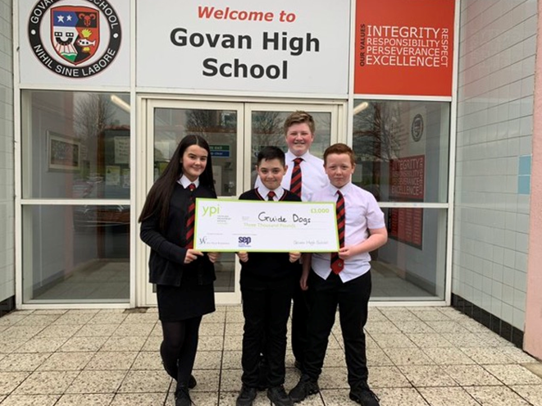
The Spiritual, Social, Moral and Cultural needs of pupils in Govan High are attended to formally through the Health and Wellbeing Programme, religious education courses and acts of religious observance. All pupils S1 to S6 attend classes and information sessions relating to Health and Wellbeing and Religious Education.

Health and Safety
Health and Safety is a very important in Govan High School. The Education Department of Glasgow City Council is responsible for the health and safety of all who work in the school and all pupils who come to the school.
Paula Wlosinski DHT is responsible for making sure that the various regulations and rules for Health and Safety are observed in the day to day running of the school.
Emergency regulations in the case of fire, rules for movement in the school, in the corridors and on the stairs have all been drawn up to ensure pupil safety.
For some subjects there are codes of practice, e.g. Art, Science, Technical, Home Economics and Physical Education. These codes provide safety rules which must be observed by pupils when attending these subject areas, e.g. wearing of safety glasses in Science, not wearing jewellery in Technical and having proper kit for PE activities.
Information in Emergencies
We make every effort to maintain a full educational service, but on some occasions circumstances arise which lead to disruption. Schools may be affected by, for example, severe weather, temporary interruption of transport or power failures. In such cases we will do what we can to keep you informed and to make you aware of any closure or reopening. We shall do this mainly through use of the school website, twitter and by use of text message and letter.
Attendance

Section 30 of the 1980 Education Act lays a duty on every parent of children of ‘school age’ to ensure that their children attend school regularly. Attendance must be recorded twice per day, morning and afternoon. Regulation 7 of the Education Regulations (Scotland) 1993 requires each child’s absence from school to be recorded in the school as authorised, that is approved by the authority, or unauthorised that is unexplained by the parent (truancy) or temporarily excluded from school.
Good attendance leads to higher pupil attainment. One week’s absence means 3% of learning lost. Parents, pupils and teachers should all work together to achieve better attendance and higher achievement.

Attendance is recorded every period during the school day. If your young person is late then this will also be recorded. This allows us to monitor pupils’ attendance and timekeeping throughout the day. Pupils who are taking part in school activities will be marked accordingly. Authorised absences include illness, medical or dental treatments and extenuating circumstances. Unauthorised absences are unexplained absences and cover truancy or if a parent provides no explanation for the absence.

Every effort should be made to avoid family holidays during term time as it both disrupts the young person’s education and reduces learning time. Parents should inform the school by letter if they are going on holiday outlining the dates and this will then be recorded as parental holiday.
If your child is absent from school you should:
- Call the Glasgow City Council absence reporting line on 01412870039 to make them aware of the absence, reason and duration if known.
- Give your young person a note on their return to school confirming the reason for the absence and the duration

If we are not notified of an absence from school then you will receive a text from the school to make you aware of this. You will also receive a text to make you aware if your child is late for school. If no communication is provided then a telephone call or a letter will be sent to you asking for an explanation. If there is no response then this will be passed to our Education Liaison Officer. A pupil with a pattern of absence may be referred by the authority either to the Attendance Council or to the Children’s Panel.

Medical Information
Should a young person become ill during the day, a parent or designated person will be contacted and asked to take them home. It is therefore essential that the school has up to date contact numbers for parents/guardians and an emergency contact. If a pupil requires treatment at hospital and a parent/designated person cannot be contacted, the pupil will be taken there in the care of a member of staff. Where a pupil has a medical condition which might affect their progress or which requires regular medication, the school should be informed in order to make suitable arrangements. The school does have a member of staff trained in first aid who will advise should a young person be injured or become ill.

Promoting Positive Behaviour
Promoting Positive Behaviour is a whole school policy which aims to promote positive behaviour in all pupils in Govan High School. The policy provides guidelines for staff to create an environment where everyone displays appropriate behaviour. All members of the school community are encouraged to act positively and show respect to one another. Pupils who display such positive behaviour will be recognised by members of staff in a variety of ways irrespective of academic ability and progress.

School Expectations (We no longer refer to this as rules)

All staff strive to promote a positive learning environment, encourage responsible citizenship and help to create an environment conducive to learning. Our young people are reminded on a daily about the importance of:

1. Being Safe
2. Being Responsible
3. Being Ready to Learn

The school has been engaging with Pivotal Education in order to train staff in dealing with challenging behaviour issues. There are 4 staff members who are now trainers and they cascade information and training to the whole staff. The focus is on building positive relationships with pupils, fresh starts and supporting each other to help each young person fulfil their potential. This training will help build mutual understanding, respect and responsibility within Govan High.

iRESPECT Merit System

The merit system is used as a form of positive recognition, where staff will acknowledge positive behaviour shown by pupils. All staff and pupils are familiar with the ‘iRESPECT’ merits as they are in line with the values of the School:

i Integrity
R Responsibility
E Equipped
S Success
P Perseverance
E Excellence
C Caring
T Time keeping

Teachers identify where pupils display these values and reward them using the SEEMIS merit system. Pupils can then achieve Bronze, Silver and Gold certificates and badges dependent upon the number of Merits that they have received and these are awarded at our termly Achievements Assemblies.

Managing Behaviour
Occasionally, some pupils do behave in an unacceptable way and this is dealt with in the most appropriate way using a variety of approaches.

Minor difficulties are overcome by counselling which may be done by the class teacher or Pastoral Care staff. Most incidents of indiscipline are recorded by teaching staff and these records are frequently appraised by Pastoral Care and senior staff. When behavioural problems become protracted, parents are informed and discussion takes place to find ways of resolving the difficulties.
Where necessary additional support can be offered e.g. learning support where behavioural problems arise through difficulties with learning or psychological support where other problems are causing difficulties. Every effort is made, in partnership with parents or guardians, to resolve behavioural problems.

However where a pupil’s behaviour is such that the work of others is continually being disrupted, or their wellbeing is being threatened and measures noted above are not proving to be successful, more serious action is taken. Ultimately, a pupil can be excluded from Govan High and this of course, is the final sanction available to the school.

Dealing with Bullying
Bullying is taken very seriously. When incidents are reported, they are fully investigated by Pastoral Care and /or senior staff and then dealt with swiftly and fairly. Parents are contacted at the earliest possible opportunity to help resolve the situation.

There are structured lessons as part of the Health and Wellbeing programme. Pupils openly discuss issues concerning bullying and are given very clear advice on how to deal with it, should they experience or witness such behaviour in school.

School Uniform
Following extensive consultation, the wearing of school uniform has now been firmly re-established.

It is the expectation that each young person will wear the full school uniform each day that they attend school. This sets the tone for the day and we encourage each young person to dress for success. The school uniform is as follows:
- Black trousers or skirt
- White shirt
- School tie
- Black footwear
- Black cardigan or jumper
- School blazer
- Black outer jacket when required
Through our school uniform we endeavour to encourage appropriate and positive attitudes to school as a place of work; create a sense of pride and identity with the school; and increase security within the school building. If uniform is clearly marked with pupil’s name, lost property can be more easily tracked down.

Details of purchasing the school tie and blazer as well as the optional school jumper and cardigan can be sought from the school office.

PE Kit
It is essential from both the hygiene and safety viewpoint for PE kit to be worn whilst taking part in physical activities. The following items are suitable:

- Gym shoes/trainers
- Shorts/gym trousers
- T-shirt/polo shirt (non-football)
- Tracksuit for colder weather
Please note all young people must also come equipped for school and carry a school bag. This includes a pen/pencil, materials needed for their subject areas and PE kit on the days required.

Grants and Claims
Parents receiving income support, job seekers allowance (income based), working tax credit (with NHS exemption), housing benefit, or council tax rebates will normally be entitled to monetary grants for footwear and clothing for their children. Approval of any requests for such grants made by parents in different circumstances is at the discretion of the director of education. Information and application forms may be obtained from schools and from Education Services.

The council is concerned at the level of claims being received regarding the loss of pupils’ clothing and/or personal belongings. Parents are asked to assist in this area by ensuring that valuable items and unnecessarily expensive items of clothing are not brought into school. Parents should note that the Authority does not carry insurance to cover the loss of such items and any claims submitted are likely to be met only where the authority can be shown to have been negligent.
School Meals
Our school provides a service which offers a variety of meals and snacks within The Fuel Zone. A breakfast and mid-morning service is also available within The Fuel Zone. Special diets for children with medical requirements can be provided. Please inform the school office. Young people who prefer to bring packed lunches are accommodated in the dining hall.

Information and application forms for free school meals may be obtained from schools and at:

https://www.glasgow.gov.uk/index.aspx?articleid=17885

Education Maintenance Allowances (EMA)
An EMA is a weekly payment worth up to £30 for students who are planning to stay on at school in post-compulsory education and who are willing to participate in an approved learning agreement at school for a minimum of 21 guided learning hours per week. Further information on full eligibility criteria and application forms can be obtained from the school.

Transport
The Education Authority has a policy of providing free transport to secondary pupils who live more than two miles from their local school by the shortest walking route. This policy is more generous than the law requires. This means that the provision of transport could be revised at any time. Parents who consider that they are eligible should obtain an application form from the school or education office. These forms should be completed and returned by the end of February for those pupils beginning school in August to enable appropriate arrangements to be made. Applications can be submitted at any point in the session but may be subject to delay whilst arrangements are made.
Where transport is provided it may be necessary for pupils to walk a certain distance to the pickup point. It is the parent’s responsibility to ensure that the young person arrives at the pickup point on time. It is also the parent’s responsibility to ensure that the young person behaves in a safe and acceptable manner. Misbehaviour could result in your child losing the right to free transport.
The education authority does not provide transport for those pupils in receipt of a placing request other than in exceptional circumstances and where appropriate legislation applies.

Parent Council
The Scottish Schools (Parental Involvement) Act 2006 has changed the arrangements for parental representation in all schools. Since August 2007, all parents are automatically members of the Parent Forum for their school and they have a right to establish a Parent Council to represent them.

The Parent Council is a group of parents selected to represent all the parents of children at the school. Parent Councils are very flexible groups and the Parent Forum can decide on the type of group it wants to represent their views. The type of things a Parent Council could get involved in include:

• Supporting the work of the school
• Gathering and representing parents’ views to the Head Teacher, education authority and Education Scotland
• Promoting contact between the school, parents, pupils and the local community
• Fundraising
• Involvement in the appointment of senior school staff

Parent Councils are recognised in law from August 2007. As a statutory body, the Parent Council has the right to information and advice on matters which affect children’s education. So, the school and the local authority must listen to what the Parent Council says and give it a proper response. Every school’s Parent Council will be different because it will be parents in each school who make the key decisions. The Parent Council is also entitled to support from the education authority in fulfilling its role.

Membership of the Parent Council
Generally, members of the Parent Council must be parents of children who attend the school and the chairperson must have a child in the school. However, the Parent Council can decide to co-opt other members from teachers and the community who will have knowledge and skills to help them. The Headteacher (or representative) has a right and duty to attend all meetings of the Council, but does not have a right to vote. The chairperson of the Govan High School Parent Council may be contacted via the school.

Communication
We aim to assist each young person in achieving their full potential. This can only be achieved when we work in full partnership with parents. This school handbook is one form of contact between the school and parents. There are other forms of contact which are also very important:
A first point of contact for most parents will be the Pastoral Care teacher responsible for the young person. Please make contact with Pastoral Care staff regarding any concerns that you have.
Letters – Letters on different topics are sent home throughout the course of each session. These may be standard letters about parents’ evenings or personalised letters relating to an individual pupil. Parents will be kept up to date about pupil progress through the tracking reports issued three times each session in addition to the full written report issued.
Formal Parents’ Nights – parents are invited into school to discuss the progress of their young person at formal parents nights which are scheduled one per year group throughout the course of the session.
Meetings – if issues or concerns arise then parents may be invited into school to discuss this with either the Principal Teacher of Pastoral Care of the DHT in charge of the year group. Likewise, if as a parent there is a problem or an issue that you would like to discuss then please do not hesitate to contact the school to arrange a meeting at a time of our mutual convenience.
Telephone and Texting – On occasion we have to contact parents quickly – perhaps because of illness or an accident. We may also use the school’s text messaging service to get a message out to all parents quickly and effectively. Please ensure that your contact details are up to date with our office staff so that you do not miss important communications.
Achievements Newsletter – Our newsletter is produced three times each session and celebrates the achievements of our young people and staff. It also gives important updates to parents on activities taking place. A copy of the newsletter can be viewed or downloaded from the school website.
Govan High School Archive
A very large collection of school photos, magazines, information about many recent and past events have been collected into a School Archives.
Enquiries/visits are welcomed by Volunteer Archivist Ian McCracken 0141-582-0090 gw10mccrackenian2@glow.sch.uk
Ian is also keen to connect with former pupils and collect their memories and any photos or other information they wish to share. Information is also available on the school website and Twitter.
Govan High Language & Communication Resource (LCR)
Govan High Language & Communication Resource (LCR) is co-located within Govan High. The LCR was formerly known as Govan High Autism Unit. The unit was opened in 2003. It caters for pupils who have an Autistic Spectrum Disorder diagnosis and are able to access the Broad General Education and Senior Phase secondary curriculum, with support, but who are unable to cope with this in a mainstream setting. The LCR occupies half of the top floor of Govan High and comprises a suite of 14 rooms, including specialist ICT and Home Economic rooms. The catchment area is the whole of the city of Glasgow. Most students have transport provided. The roll is capped at 40.

The teaching staff allocation for 2019 - 20 is 14 FTE. The LCR leadership team consists of the DHT and the PT. The majority of teaching staff have undergone postgraduate qualifications in Support for Learning and/or Autism. Two of the teachers have full Chartered Teacher status.
The work of the teaching staff is ably complemented by a number of support staff. All support staff undertake regular autism awareness training. The LCR has a part-time Clerical Assistant and 12 FTE Support for Learning Workers. A number of staff have been trained in, and deliver, additional services, such as Sleep Counselling and Bereavement Counselling for pupils and their families.

Nurture
The LCR is a very nurturing environment, and, while the emphasis is on Learning & Teaching, the additional support needs for our pupils will be a priority – the pupils will experience more successful learning if they feel comfortable, cared for and secure in their classrooms.

The LCR follow Glasgow’s ‘Towards a Nurturing City’ guidelines and we incorporate the 6 Nurturing Principles in our ethos:
- Children and young people’s learning is understood developmentally
- The classroom / school offers a safe base
- The importance of nurture for the development of self esteem
- Language is a vital means of communication
- All behaviour is communication
- The importance of transition in young people’s lives
Partnerships
The partnership between home and school is regarded as an essential part of the education of our pupils. Staff work closely with Psychological Services and allied health professionals to meet the needs of our pupils.

There are close links with Govan High to facilitate inclusion as well as to promote collaborative working between staff. There are also strong links with FE colleges in the city. Our pupils also make good use of community facilities such as the Glasgow Club gym at Pirie Park Primary, Bellahouston Allotments and Pollok Park. We strive to enrich our pupils by making the most of environments beyond the classroom. We also work closely with our Active Schools Coordinator and run a wide variety of sport related (and sport free) lunch clubs.

The School Year

GOVAN HIGH SCHOOL –
HOLIDAYS AUGUST 2020 – JUNE 2021

Return from Summer Break  Inset days 1 & 2 | Wednesday 14th August 201  Inset days Monday 12th and Tuesday 13th August 2019
September Weekend | Friday 27th and Monday 30th September 2019
Inset day 3  First Mid Term  Inset day 4 | Friday 11th October 2019  Monday 14th October to Friday 18th October 2019  Friday 29th November 2019
Christmas/New Year | Thursday 19th December 2019 to Friday 3rd January 2019 (inclusive)
Inset day 5  Mid Term  Inset day 6 | Friday 7th February 2020  Monday 10th February & Tuesday 11th February 2020  Wednesday 12th February 2020
Spring Holiday | Friday 3rd April to Friday 17th April 2020 inclusive  Note: Good Friday is 10th April  And Easter Monday is 13th April
May Day | Friday 8th May 2019
Inset day 7  May Weekend | Monday 11th May 2020  Friday 22nd May and Monday 25th May 2020
Summer | School closes Wednesday 24thJune 2020
Return from Summer Break –  Inset Days 1 & 2 | Thursday 13th August 2019  (Inset days Tuesday 11th and 12th August 2020)

THE FREEDOM OF INFORMATION (SCOTLAND) ACT 2002

The Freedom of Information (Scotland) Act 2002 enables any person to obtain information from Scottish public authorities. The Act applies to all Scottish public authorities including: Scottish Executive and its agencies; Scottish Parliament; Local Authorities; NHS Scotland; Universities and further education colleges; and the Police.

Public authorities have to allow access to the following information:
• The provision, cost and standard of its service;
• Factual information or decision-making
• The reason for decisions made by it.

The legal right of access includes all type of ‘recorded’ information of any data held by the Scottish public authorities. From 1 January 2005, any person who makes a request for information must be provided with it, subject to certain conditions.

Further information is provided on the Glasgow City Council web-site:
www.glasgow.gov.uk
Internet facilities are provided at all Glasgow City Council Public Libraries and Real Learning Centres.
COMMENTS AND COMPLAINTS

Glasgow City Council complaints procedures are available:https://www.glasgow.gov.uk/complaints
Customer Care Team
Customer & Business Services
Glasgow City Council
City Chambers
Glasgow G2 1DU

Tel: 0141 287 0900
e-mail: customercare@glasgow.gov.uk or education.customerservices@glasgow.gov.uk

If we are asked to provide our information to the SPSO when they are looking into a case, it is better if we have a consistent process. For information, we should respond to a frontline response within 5 working days and 20 days if it is an investigation – this information is contained within the link.

Data Protection – use of information about children and young people and parents/carers
We collect information about children and young people attending school (and also about parents/carers, emergency contacts etc. provided in the annual data check) to allow us to carry out the Council’s functions as the education authority for the City of Glasgow. This may sometimes involve releasing personal information to other agencies and other parts of the Council, particularly in relation to child protection issues or criminal investigations, and it may also be used for research purposes (see the link below for more details regarding this).
Information held by the school is, in legal terms, processed by Glasgow City Council. The Council is registered as a data controller under the Data Protection Act 1998 (number Z4871657) and all personal data is treated as confidential and used only in accordance with the Data Protection Act and the Information Use and Privacy Policy approved by the City Council. For more information on how we use personal information, or to see a copy of the Information Use and Privacy Policy, see www.glasgow.gov.uk/privacy.

Although this information is correct at time of printing, there could be changes affecting any of the matters dealt with in the document
a) before the commencement or during the course of the school year in question
b) in relation to subsequent school years.

Useful Contacts

Parentzone Scotland is a unique website for parents and carers in Scotland, from early years to beyond school. The website provides up-to-date information about learning in Scotland, and practical advice and ideas to support children’s learning at home in literacy, numeracy, health and wellbeing and science. Information is also available on Parentzone Scotland regarding additional support needs, how parents can get involved in their child’s school and education. Furthermore, the website has details about schools including performance data for school leavers from S4-S6; and links to the national, and local authority and school level data on the achievement of Curriculum for Excellence levels.
Useful websites and contacts

Education Scotland www.education.gov.scot
National Parent Forum of Scotland www.npfs.org.uk

Connect

Connect is a national organisation that provides advice and resources for parents and carers. www.connect.scot

Enquire Scotland

Enquire is a national advice service for families with additional support needs. www.enquire.org.uk

Education Services
City Chambers East
40 John Street
Glasgow G1 1JL

Tel: 0141 287 2000

www.glasgow.gov.uk

