Public Health
West House
Gartnavel Royal Hospital
1055 Great Western Road
Glasgow G12 0XH

September 2021

Dear Parent/Carer

Secondary school

I write to confirm that your child may have had ‘low risk’ contact with a person who has COVID-19. This means they may have shared a classroom or had some other low risk contact in school.
There is no need for your child to isolate unless you are contacted separately by Test and Protect and asked to do so. Your child should continue to attend if they are well and do not have to self-isolate for any other reason. Whole classes are no longer asked to self-isolate if someone in the class tests positive for COVID-19. Your child will only be identified as a contact if they have had prolonged close contact with the case – e.g. same household, overnight stays.

Please be reassured that for most people coronavirus (COVID-19) will be a mild illness. Children are at particularly low risk of illness from coronavirus infection. For those people who are eligible, vaccination is highly effective at preventing severe disease.

What we are asking you to do;
- Please be vigilant for symptoms of COVID-19. If you or anyone in your household develops symptoms of COVID-19 then all household members must self-isolate. A PCR test should be booked as soon as possible for anyone who has symptoms. Your whole household should stay at home until the test result comes back.
- Wherever possible your child should take a lateral flow test before returning to school, and should continue to test regularly (twice-weekly) thereafter. Your child should not take a lateral flow test if they have tested positive for COVID-19 in the last 90 days. Testing can help to reduce the likelihood of spread in schools by catching infections early. If the test is positive your whole household should self-isolate and you should arrange a PCR test for your child. Please ensure that all lateral flow test results, whether positive, negative or void, are recorded on the online portal at: www.covidtest.scot or by phoning 119.

To help reduce the risk to your family and your school community, please also follow wider Scottish Government guidance;
- Arrange vaccination as soon as possible, if you or anyone eligible in your family have not yet been vaccinated. Further information is available at www.nhsinform.scot/covid-19-vaccine. Vaccination is our best defence against COVID-19 causing anyone to become seriously unwell.
- Wear a face covering in line with guidance, keep your distance, keep rooms ventilated, and wash your hands with soap and water regularly.
- You and the rest of your family, including primary school-aged children, can access free test kits through the Universally Accessible Testing programme, which is available to everyone in Scotland.

How to arrange a COVID-19 test

Lateral flow tests: Free test kits are available to all secondary school children from the school. Please contact the school directly if they have any problems accessing tests. Free at-home LFD test kits are available for you and your primary-school aged children by collection from COVID test centres or pharmacies, or delivery by ordering online. More information can be found at: www.gov.scot/publications/coronavirus-covid-19-getting-tested/pages/no-covid-symptoms.

PCR tests: Book a test at NHS Inform for your nearest COVID-19 test site. There are drive-through, walk-through, and mobile testing units across Scotland which are open from 8-am until 8pm, 7 days a week. A full list of sites can be found at Gov.Scot. Or you can order a home PCR test kit online, or by calling 119. A test will then be delivered to your home. To return you can either drop the test at your nearest priority post box, or if you are unable to go out, you can also call 119 to book a courier collection from your home.

Further Information
For general Coronavirus Frequently Asked Questions and information: https://www.parentclub.scot/topics/coronavirus/coronavirus-faq?age=0 and https://www.nhsinform.scot/illnesses-and-conditions/infections-and-poisoning/coronavirus-covid-19

Yours sincerely

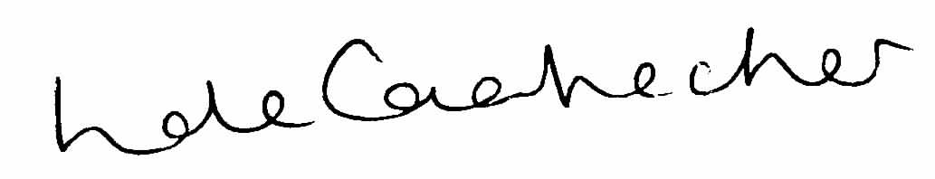

Linda de Caestecker
Director of Public Health, NHS Greater Glasgow and Clyde

