Govan High School Handbook – appendix I – subject information
English
Welcome to the English Department. Our Course Outlines are as follows:
S1 - S3 – Curriculum for Excellence English
English in S1-S3 follows a Broad General Education. Pupils will be given the scope to enhance their skills in the four key elements of Literacy, Reading, Writing, Talking and Listening.

Assessment will be internal and this will determine whether they progress to National 4 or National 5 in S4.

Class work will be a wide mix of personal reading, studying a variety of texts, writing in a variety of styles and solo, group and class presentations and discussions.

Homework will be as and when needed, this include formal written exercises, reading, carrying out research, revising for examinations or thinking and acting activities such as learning vocabulary.
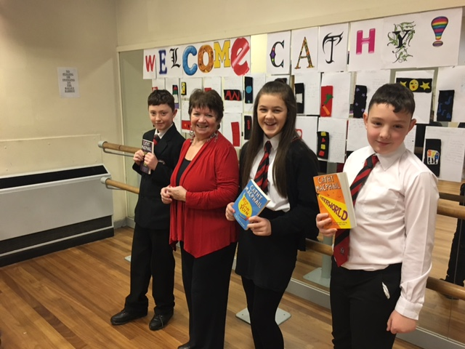

Visiting author Cathy McPhail with S1 pupils
S4/5 – National 4 and National 5 English
At the end of S3 pupils are selected to progress either to National 4, or National 5 English, depending on their performance over the course of S1-3.

Pupils sitting National 4 will be internally assessed throughout the year and must pass all four Units in order to pass the course. These Units are: Creation and Production, which involves pupils creating and producing straightforward written texts and taking part in straightforward spoken interactions; Analysis and Evaluation, which involves the pupils studying and analysing written, visual and spoken texts; the Added Value Unit, which involves researching a topic and producing either a written report or a five minute presentation. Finally they will need to have passed the Literacy Unit.

Class work will be a wide mix of personal reading, studying a variety of texts (poetry, novels, short stories, media and drama) writing in a variety of styles and solo, group and class presentations and discussions.

Homework will be as and when needed, this include formal written exercises, reading, carrying out research, revising for examinations or thinking and acting activities.

Pupils sitting National 5 will complete 3 units plus sit a final exam and submit a written folio. National 5 is significantly more demanding than National 4 and pupils must be prepared to commit to self-directed study and revision throughout the year.

In the Analysis and Evaluation Unit pupils will study a variety of texts – including, at National 5, set Scottish texts - to further develop analysis, reading and listening skills. In the Creation and Production Unit pupils will further develop their speaking and writing skills and produce detailed texts in these forms. They may also be entered for a Literacy unit, which assesses their Reading, Writing, talking and Listening skills. The Course Assessment is split in to two components: a reading question paper, worth 70% of the marks, split in two again: 30% on Close Reading and 40% on analysing two previously studied texts (one of which must be a Scottish text). The final 30% is gained through submission of a portfolio of two written pieces: one creative and one discursive. Pupils must pass the Course Assessment and both Units to gain a National 5 qualification.
Higher
Progression from National 5 is to Higher, which will follow a similar structure to National 5, but the level is more difficult. In the Analysis and Evaluation Unit pupils will study a variety of texts – including set Scottish texts - to further develop analysis, reading and listening skills. In the Creation and Production Unit pupils will further develop their speaking and writing skills and produce detailed texts in these forms. They will also study Reading for Understanding, Analysis and Evaluation. They must submit a writing folio of 2 essays (30%) and the external exam (70%).

Drama is currently offered to pupils in S1 and S2, and this will be extended to S3 and Senior Phase next session. In Drama, pupils will learn about specific drama skills, including voice, movement and characterisation, as well as being introduced to lighting, sound and other theatre arts. They will be expected to learn and use associated drama and theatre terminology when describing and evaluating their work. Pupils will explore a variety of themes, issues, topics, contexts and situations in a creative and imaginative manner and will be required to apply their knowledge and creativity to both practical and theoretical tasks.
Using new and existing skills in a variety of different contexts, pupils will create, develop and rehearse pieces of work where they have ownership, having selected appropriate ideas, concepts and dramatic techniques to enhance the performance, before using presentation skills and performing their work to an audience.
Art & Design
S1 - S3
During the first, second and third year Art and Design course, all Learners become familiar with a wide range of materials and techniques in both two and three dimensions. They will also become familiar with visual elements such as line, colour, texture, shape and form. Learners are given the opportunity to follow and understand the design process and to solve simple design problems.

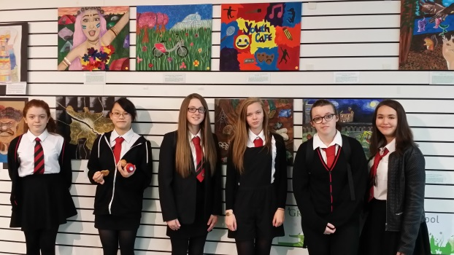

S4/5 – National 4 and National 5 Art
At the end of S3 pupils can chose to progress in Art. They will then progress either to National 4, or National 5 Art, depending on their performance over the course of S1-3.

Pupils sitting National 4 will be internally assessed throughout the year and must pass all three Units in order to pass the course. These Units are: Design in which learners will describe the things that have inspired and influenced designers and their work and Produce creative design ideas and development work in response to a given design brief.

Expressive in which learners will describe the things that have influenced and inspired artists and their work and produce creative ideas for expressive art work, and the Added Value Unit, in which they should produce a piece of expressive art in response to stimuli and produce a piece of design work in response to a design brief.

Pupils sitting National 5 will complete 2 units plus sit a final exam. The 2 units are Design in which learners will analyse the factors influencing designers and design practice, and produce creative design ideas and development work for a design brief; and Expressive in which learners will analyse the factors influencing artists and practice and produce creative development ideas for expressive artwork. In the final written exam leaners must give their thoughts and opinions about the work of various artists and designers. This element is externally assessed by a written examination.

Higher
The Higher course, followed by pupils in S5 and S6, is arranged in two units plus a written examination. In the Expressive unit - Learners will analyse the factors influencing artists and art practice as well as produce creative development ideas for expressive artwork. In the Design unit - Learners will analyse the factors influencing designers and design practice and produce creative design ideas and development work for a design brief. There will also be a 2 hour written exam.

Advanced Higher
Candidates are required to produce an extensive portfolio of work (DESIGN or EXPRESSIVE) based on their selected theme, as well as writing a Critical Analysis (1,700 words) plus an evaluation.
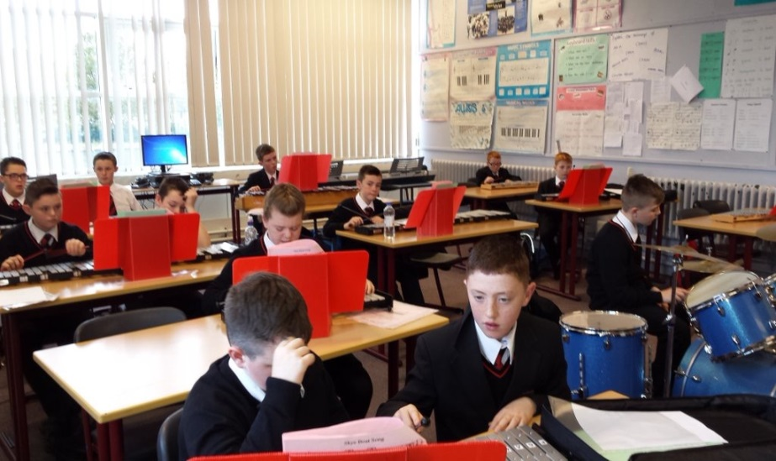
Music
Teachers
Mrs E. Bonner (P.T.)
Mr S. Rodger

Instructors
Mr W. Shaw woodwind
Mr J. Lang brass
Mr C. Reilly guitar
Mr A. Cowie drum-kit
S1 - S3 BGE
Pupils enjoy making music by performing, listening and creating music. At S1 and S2 pupils learn to play and develop skills on keyboard, recorder, drum-kit, voice, tuned percussion and ukulele/guitar. Listening and literacy are integrated within each unit of work. Pupils also compose in a variety of styles e.g. melody for an orchestral instrument, a Scottish dance, reggae.

National 4 - The National 4 Music Course enables pupils to perform music, create original music and develop knowledge and understanding of music and musical literacy. Pupils also develop an understanding of the external factors that influence composers and their works. Pupils must pass units in Performing, Composing, Understanding Music and The Added Value Unit in which they must perform music in a range of musical styles on another instrument.

National 5 - The National 5 Music Course enables pupils to perform challenging music, create original music and broaden their knowledge and understanding of music and musical literacy. The Course also enables pupils to develop knowledge of the social and cultural factors that influence music. Pupils must pass units in Performing, Composing and Understanding Music. There is also a written exam.

Higher - The Higher Music Course provides a broad practical experience of performing, creating music and develops related knowledge and understanding of music. Pupils develop their skills and creative capabilities as musicians and gain the skills they need to perform, create music and to confidently discriminate between music concepts and styles. Pupils must pass units in Performing, Composing and Understanding Music. There is also a written exam worth 40%.

Advanced Higher - The Advanced Higher Music Course develops pupils’ skills in performing, creating, understanding and analysing music. Pupils develop the skills they need to perform challenging music with musical, technical accuracy and fluency, while realising composers’ intentions, and develop their own composing skills in sophisticated and creative ways. Pupils must pass units in Performing, Composing and Understanding Music. As with National 5 and Higher, there is a written exam worth 40%.

Extra-curricular activities provide opportunities for wider achievement, building confidence and self-esteem. Pupils are given choices of musical activities to attend where they develop the skills and attributes which they will need for learning, life and work. These include a vocal group, a band and a pipe band.

Mathematics

Mathematics – S1
S1 maths consists of a wide range of topics that build on previously learned knowledge from Primary school. Pupils will work at their appropriate level in broad general education (BGE) up to 4th Level. Teaching is done through varying learning activities including the whole class, group and individual lessons. Throughout the first year pupils are encouraged to develop their numeracy skills whilst also learning new information.
Topics that are covered in S1 include: time, decimals, fractions, percentages, measurement, information handling, money, coordinates, 2D & 3D shapes and symmetry. A weekly homework will be issued to consolidate learning.

Mathematics - S2
Pupils will continue to further develop skills and knowledge that have been taught in first year. Teaching is done through varying learning activities including the whole class, group and individual lessons. Pupils will continue to work on their numeracy skills through lesson starters, classwork and homework.
They will also cover new topics that include: equations, angles, enlargement / reduction diagrams, scales and patterns. A weekly homework will be issued to consolidate learning.

Mathematics – S3
BGE is further developed in S3 in order to prepare pupils for National qualifications in S4 at either National 4 or National 5. Teaching is done through varying learning activities including the whole class, group and individual lessons. Topics previously taught during S1 and S2 will be further investigated and extended in order to challenge pupils and help them to achieve their best. Topics in S3 will include: Pythagoras, further equations and basic trigonometry. Throughout S1-S3 pupils will be encouraged to problem solve when they are faced with challenging questions. They will be presented with a mixture of calculator and non-calculator questions. Tasks should be completed either individually or as part of a pair/group. Homework will also be given weekly as it is an important part of the course which reinforces learning.

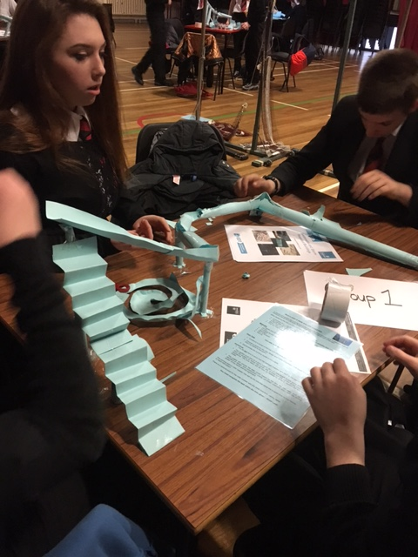

National 3 Lifeskills Maths
National 3 Maths consists of three units: Numeracy; Manage Money and Data; and Shape, Space and Measure. Numeracy covers basic Mathematical skills such as working with fractions, decimals and percentages; making calculations using time; measurement; and reading information from charts and graphs. Manage Money and Data covers financial maths such as reading payslips, calculating wages, budgeting, comparing costs as well as constructing and interpreting charts and graphs. Shape, Space and Measure covers calculating the area of 2d shapes and the volume of 3d shapes, working with patterns and formulae, and using the scale factor.

National 4 Maths
National 4 Maths consists of three units: Numeracy, Expressions and Formula and Relationships. The Numeracy unit covers working with fractions, decimals and percentages; making calculations using time, speed, distance, ratios and money; measurement; and reading information from charts and graphs. Expressions and Formulae covers topics in Algebra, symmetry, gradient calculations and constructing and interpreting charts and graphs. Relationships covers solving equations, changing the subject of a formula, scale factor, Pythagoras, angles and trigonometry. There is a focus on solving real life problems in all three units. A weekly homework will be issued to consolidate learning.

National 5 Maths
National 5 Maths consists of three units: Expressions and Formulae, Relationships and Applications. Expressions and Formulae covers powers, roots and surds; volume; factorising and expanding algebraic expressions and gradient. Relationships covers solving equations and inequations, quadratics, trigonometry and scale factor. Applications covers fractions, percentages, vectors, further trigonometry and statistics. National 5 is a challenging, fast-paced course with an emphasis on problem solving. A weekly homework will be issued to consolidate learning.

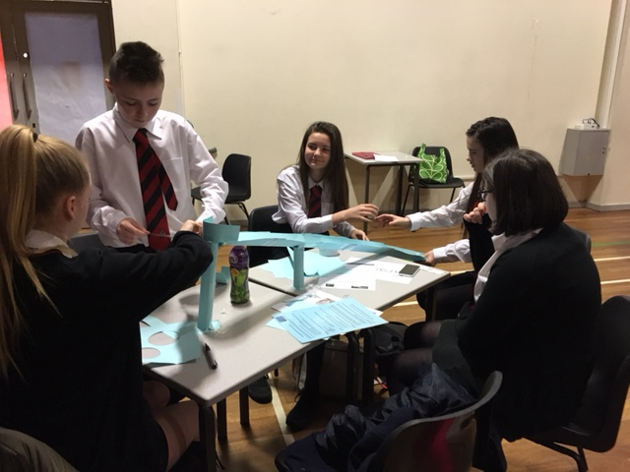

Higher Maths
Higher Maths consists of three units: Expressions and Functions, Relationships and Calculus and Applications. Expressions and Formulae builds on the algebra learnt in National 5 to cover topics such as polynomials, transformations of graphs and logarithmic functions. Relationships and Calculus teaches the basics of integration and differentiation and builds on the trigonometry from National 5. The Applications unit focuses on applying the Mathematical skills from the rest of the course in real life and abstract situations. Higher Maths teaches exceptional problem solving and reasoning skills and is highly sought after by employers.

Social Subjects

Social Subjects in S1 – S3 follows a Broad General Education. In S1 to S2 pupils will have the opportunity to learn about Geography, History and Modern Studies. In S3 pupils must choose which Social Subject to carry on into S3.

This session in S1 – S2 pupils will study topics such as the Ancient Egyptians, Slavery, The Scottish Wars of Independence, Scotland in 21st Century and The Developing World to name a few. In S3 pupils follow a curriculum that allows for a natural progression into the Senior phase, that equips our young people with the knowledge and understanding and skills to succeed at National 4/5 level.
Learning in Social Subjects at BGE level will allow our young people to develop an understanding of...
- History, heritage and the culture of Scotland and to appreciate local and national heritage within the world;
- How people live today and in the past;
- Economic, social and environmental issues on a local and global scale.
- Democracy and the importance of active citizenship in a school and local community
As well as learning about the social subjects, all units of work allow our young people to develop their skills in important curricular areas such as literacy, numeracy and health and well-being.

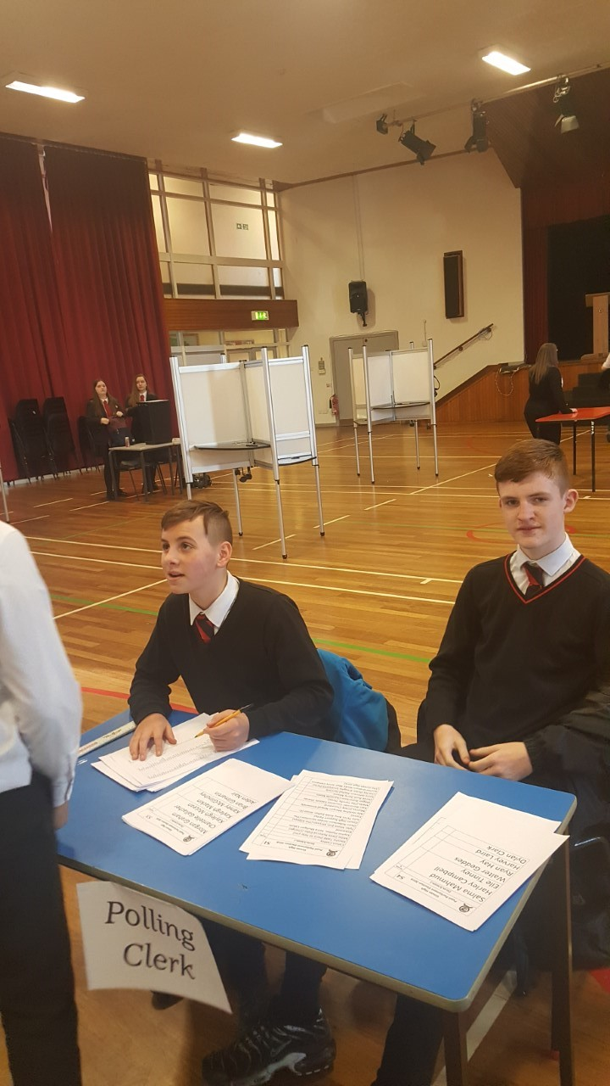

Pupil Parliament Elections
Due to the diverse nature of the Social Subjects, especially in S1-S3, independent study at home will take on a variety of exercises and tasks. The classroom teacher will provide homework when they feel it is appropriate and fits in with the work of the class and the needs of the pupils but will be issued at least once per week to all pupils.
- Traditional “ink exercise” homework tasks based on exam-style questions
- ‘Tweet Sheet’ Summary: Pupils have to sum up the main points of the lesson in 140 characters.
- ‘Sum it Up’: Pupils should summarise key learning concepts in 20 words.
- ‘Question Time’: Pupils should prepare a question and answer for a recap as a starter activity for the previous lesson.
- ‘WWW and EBI: What Went Well and Even Better If’: Pupils are asked to write and review their progress at the end of the week including what they have done well this week and what they think they need to improve upon.
- ‘I Want to Know’: Pupils have to write down a question that they want to find out from the next lesson or a question that they are struggling with.
- Pupils may be also issued with more formal homework during topics as and when necessary and will be given deadlines for submission, e.g. relevant worksheets, investigation/project

Essential to all the Social Subjects is the need for pupils to learn about the world they live in by watching, listening and reading about their world. This should involve:
- reading quality newspapers e.g. The Herald and researching the internet: e.g. BBC
- watching news, documentaries and current affairs on TV e.g. Channel 4 News
- Listening to the radio. E.g. Radio 4 The Today Programme
- Having a conversation with friends, family and relatives about current affairs, history or business. It’s amazing what you can learn from your parents!

Assessment is internal; pupils will complete a minimum of two assessments per unit of work. These assessments will help determine whether they progress to National 4 or 5 by the end of S3.
National 4 and 5 Geography
At the end of a Broad General Education (end of S3), pupils advance to the Senior phase where they will study Geography at National 4 or 5 level depending on their performance and progress over the course of S1 –S3.
At both National 4 and 5 level pupils study the following units of work.
Physical Environments | Key topics include: location of landscape type; formation of key landscape features; land use management and sustainability; and weather. Landscape types will be chosen from: glaciated upland; upland limestone; coastal landscapes; and rivers and valleys.
Human environments | Key topics include: contrasts in development; world population distribution and change; and issues in changing urban and rural landscapes.
Global Issues | Key topics include climate change; the impact of human activity on the natural environment; environmental hazards; trade and globalisation; tourism and health. Pupils must study two of the topics mentioned.

Pupils learning at National 4 level will be internally assessed throughout the year and must pass all four units of work in order to pass the course and progress to National 5 level. The National 4 and 5 courses develop a range of geographical skills and techniques. Pupils gain a straightforward understanding of the ways in which people and the environment interact in response to physical and human processes at local, national, international and global scales.
At National 5 level the course assessment has two components; a question paper and an assignment. The question paper will require the learner to demonstrate breadth of skills, knowledge and understanding drawn from the mandatory content of the Course. The assignment will require our young people to demonstrate challenge and application related to an appropriate geographical topic or issue. This will account for 25% of their final mark.

Higher Geography
Progression from National 5 is to Higher, which will follow a similar structure to National 5. But the level is more difficult. The Higher Geography Course develops learners’ understanding of our changing world and its human and physical processes in local, national, international and global study contexts. Opportunities for practical activities including fieldwork are incorporated into the course, so that pupils interact with their environment. Similar to the National 5 course, the course assessment has two components; a question paper and an assignment. The question paper accounts for 60 marks of the 90 on offer. The assignment accounts for the remaining 30 marks.
National 4 and 5 History
At the end of a Broad General Education (end of S3), pupils advance to the Senior phase where they will study History at National 4 or 5 level depending on their performance and progress over the course of S1 –S3.
At both National 4 and 5 level pupils study the following units of work.
Historical Study:  Scottish | In this Unit, pupils will develop techniques to comment on historical sources. Events and themes of Scottish history may be studied from the Medieval, Early Modern or Later Modern period. Learners will develop knowledge and understanding of an area of historical study.
Historical Study:  British | In this Unit, learners will develop techniques to comment on the impact of a historical development. Events and themes of British history may be studied from the Medieval, Early Modern or Later Modern period. Learners will develop knowledge and understanding of an area of historical study.
Historical Study:  European and the World | In this Unit, pupils will develop techniques to comment on the factors contributing towards a historical development. Events and themes of European and world history may be studied from the Medieval, Early Modern or Later Modern period. Pupils will develop knowledge and understanding of an area of historical study.

Pupils learning at National 4 level will be internally assessed throughout the year and must pass all four units of work (one of which is the Added Value Unit) in order to pass the course and progress to National 5 level. The National 4 and 5 courses allow our young people to gain a straightforward knowledge and understanding of the factors contributing to, and the impact of, historical events. They also develop the skills of investigating historical events and forming views, and of explaining historical events and drawing straightforward conclusions.
At National 5 level the course assessment has two components; a question paper and an assignment. The question paper will require the learner to demonstrate breadth of skills, knowledge and understanding drawn from the mandatory content of the Course. The assignment will require the learner to demonstrate challenge and application related to an appropriate historical question or issue. This will account for 25% of their final mark.

Higher History
Progression from National 5 is to Higher, which will follow a similar structure to National 5. But the level is more difficult. The Higher History Course allows our young people to acquire breadth and depth in their knowledge and understanding of the past through the study of Scottish, British, European and world contexts in a variety of time periods. Options cover topics from the medieval, early modern and later modern periods, and include elements of political, social, economic and cultural history. Similar to the National 5 course, the course assessment has two components; a question paper and an assignment. The question paper accounts for 60 marks of the 90 on offer. The assignment accounts for the remaining 30 marks.
National 4 and 5 Modern Studies
At the end of a Broad General Education (end of S3), pupils advance to the Senior phase where they will study Modern Studies at National 4 or 5 level depending on their performance and progress over the course of S1 –S3.
At both National 4 and 5 level pupils study the following units of work.
Democracy in Scotland and the UK | Pupils will develop a detailed knowledge and understanding of...  - democracy in Scotland and the United Kingdom  - UK political structure including the place of Scotland within this and the debates around this arrangement  - the main institutions and organisations which make up political life in their chosen context (either Scottish or UK political system).  - the ways in which society is informed about the political system, and able to participate in, and influence, the political system.  - their rights and responsibilities in contemporary democratic political society.
Social Issues in the UK | Pupils will develop a detailed knowledge and understanding of...  - social issues in the United Kingdom, either Social Inequality OR Crime and Law.  - Social inequalities: the causes and consequences of social inequality  - Crime and Law: the causes of crime, the impact of crime on individuals and society and the role of individuals, the police, the legal system and the state in tackling crime.
International Issues | Pupils have a choice of contexts for study, either a socio/economic and political study of a significant world power or a contemporary world issue.

Pupils learning at National 4 level will be internally assessed throughout the year and must pass all four units of work (one of which is the Added Value Unit) in order to pass the course and progress to National 5 level. The National 4 and 5 courses gives pupils a detailed understanding of the democratic process and of social and economic issues at local, Scottish, national and international levels..
At National 5 level the course assessment has two components; a question paper and an assignment. The question paper will require the learner to demonstrate breadth of skills, knowledge and understanding drawn from the mandatory content of the Course. The assignment will require the learner to demonstrate challenge and application related to an appropriate historical question or issue. This will account for 25% of their final mark.
Higher Modern Studies
Progression from National 5 is to Higher, which will follow a similar structure to National 5. But the level is more difficult. The Higher Modern Studies Course develops learners’ knowledge and understanding of contemporary political and social issues in local, Scottish, United Kingdom and international contexts. In these contexts, learners develop an awareness of the social and political issues they will meet in their lives. Similar to the National 5 course, the course assessment has two components; a question paper and an assignment. The question paper accounts for 60 marks of the 90 on offer. The assignment accounts for the remaining 30 marks.
Spanish Curriculum
Our BGE Spanish Course is an exciting course which aims to prepare our young people to become responsible citizens in a global world, fostering an awareness and appreciation of the Spanish culture.

Throughout this course, pupils have the opportunity to develop the four skills of Listening, Reading, Talking and Writing in a variety of different contexts, while also developing core Skills for Learning Life and Work such as ICT and collaborative working skills. Our curriculum allows pupils to access the experiences and outcomes at CFE Levels 3 and 4. Each topic is progressive and builds upon prior learning. Learning is interactive, accessible, challenging and uses the most up to date and engaging resources to give our young people real purpose to their learning.

Our learning environment provides challenge for all but at the same time takes into consideration the values, needs and abilities of all learners. As such, all pupils are challenged to produce work of the highest standard at an appropriate level. Skills development is on-going and is supported by formative and summative assessment to evaluate learning.

By the end of S1 in Spanish, pupils should be able to speak and write about themselves, their family and their school in a basic way. They should also be able to access appropriate Reading and Listening activities on these topics.

By the end of S2 in Spanish, pupils should be able to speak and write about their hobbies, where they live, food and holiday plans in an extensive way. They should also be able to access appropriate Reading and Listening activities on these topics.

The Spanish S3 course is engaging, purposeful, experiential and challenging. Pupils are exposed to more mature topics with more breadth and depth than those in S1 and S2. Pupils are also given some experience of National level coursework to prepare them for the Senior Phase. Through film, pupils are exposed to cultural issues and as such develop their analytical skills both in English and in Spanish.

By the end of S3 in Spanish, pupils should be able to speak and write about their school, family, area and hobbies.

The Faculty of Citizenship recognises the importance of homework as an integral part of the BGE Curriculum. Homework issued in Spanish relates directly to the topic/skill currently being developed in class. All homework, whether learning or written, is designed to underpin and reinforce understanding of learning. Homework may take the form of learning/memorising/revising (vocabulary and grammar), Reading/Writing tasks or preparation for Listening and Talking activities. Homework will be issued at least once a week and will be marked through a combination of Teacher and Peer Marking.

National 4 and 5 Spanish

At the end of a Broad General Education (end of S3), pupils advance to the Senior phase where they will study Spanish at National 4 or 5 level depending on their performance and progress over the course of S1 –S3.
At both National 4 and 5 level pupils study the following units of work. Pupils will also be required to complete an Added Value Unit at National 4 Level.
Understanding Language | The purpose of this Unit is to provide pupils with the opportunity to develop reading and listening skills in the modern language and to develop their knowledge of straightforward language in the contexts of society, learning, employability, and culture.
Using Language | The purpose of this Unit is to provide pupils with the opportunity to develop talking and writing skills in the modern language, and to develop their knowledge of straightforward language in the contexts of society, learning, employability, and culture.

Pupils learning at National 4 level will be internally assessed throughout the year and must pass all units of work in order to pass the course and progress to National 5 level. The National 4 and 5 courses develop literacy skills by giving learners opportunities to read, listen, talk and write in Spanish. This course enables our young people to understand and use a modern language, to apply their knowledge of a modern language, and to develop planning, research and language skills.

At National 5 level the course assessment has three components; a question paper for ‘Reading and Writing’. A second question paper for ‘Listening’ and the third component is performance and requires pupils to talk in Spanish.

Higher Spanish
Progression from National 5 is to Higher, which will follow a similar structure to National 5. But the level is more difficult. The Higher Spanish Course enables pupils to read, listen, talk and write in Spanish, and to understand and use a modern language in relevant situations. Learners also develop language skills of translation, and apply knowledge and understanding of the modern language.
Similar to the National 5 course, there are three components; question paper 1 is ‘Reading and Directed Writing’. The second question paper is ‘Listening and Writing’. The final component is performance and requires pupils to talk in Spanish.

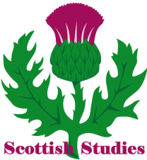
The Faculty of Citizenship – Additional Awards
Scottish Studies
The purpose of this Award is to allow learners to broaden their knowledge of Scotland whilst developing and applying the skills, knowledge and understanding relevant to their chosen subject areas. Learners will have a choice of Units, from a range of subject areas, which they can study in a Scottish context.

The main aims of the Award are to give learners the opportunity to:

- develop and apply skills, knowledge and understanding in their chosen subject areas
- make connections across these areas by studying them in a Scottish context
- develop an understanding of the contribution that Scotland and its people, past and/or present, have made and continue to make in these areas
- reflect on the place of Scotland within the wider context of the United Kingdom, Europe and/or the rest of the world
- explore an aspect of Scottish Studies that is of particular interest to them
- develop the skills of planning, researching, selecting and using information, and skills of reflection
- develop, with minimum support, their abilities to become independent learners

Our young people must complete the mandatory Scottish Studies: Scotland in Focus unit. They will also complete three Units from at least two of the following groups:

Group 1 Language and Literature
Group 2 Society and Environment
Group 3 Arts and Culture
Group 4 Business, Industry and Employment

There are a number of subject areas within each of these groups. Learners can select only one Unit from any individual subject area within a group. These must be delivered and assessed in a Scottish context.

In session 2016/17 the following units were offered:-

Society and Environment | Geography – Physical environments with a Scottish Context
Arts and Culture | Media – Analysing media content with a Scottish Context
Business, Industry and Employment | Travel and Tourism – Scotland

Assessment
There is no final exam; all pupils are assessed internally by completing assessment outcomes for each unit of work undertaken.

To achieve the Course award the candidate must successfully achieve all the Units which make up the Course.

Travel and Tourism – National 4 and 5
The National 4 and 5 Skills for Work: Travel and Tourism Courses are an introductory qualification in travel and tourism. It develops the skills, knowledge and attitudes, needed for work in the travel and tourism industry.
Pupils will develop:
- skills to become effective job-seekers and employees
- skills to deal effectively with all aspects of customer care and customer service in travel and tourism
- the product knowledge and skills to deal effectively with customer enquiries in relation to travel and tourism in Scotland, the rest of the United Kingdom and worldwide
The Course will enable our young people to experience, develop and reflect on general and specific practical skills, knowledge and understanding, together with employability skills and attitudes needed to work in the travel and tourism industry.
The general aims of this Course are to:

- Provide pupils with a broad introduction to the travel and tourism industry
- Allow pupils to experience a range of work related activities in relation to Travel and Tourism industry
- Encourage pupils to develop skills for learning and life as well as work
- Build pupils’ confidence
- Encourage pupils to take greater responsibility for their own learning and development
- Prepare pupils for progression to further education, training or employment

In this way it is hoped that our young people who undertake the Course will develop a wide range of skills which will add to their overall broad general education. Specifically it is hoped that they will gain an awareness and capability to become an effective employee in the Travel and Tourism Industry and also gain a broader range of transferrable skills.

Successful completion of the Course will enable our young people to:

- Progress to other SQA Travel and Tourism Courses or to Scottish Vocational Qualifications (SVQs) in Travel and Tourism
- Further Education
- Employment in the Travel and Tourism industry

Assessment

There is no final exam; all pupils are assessed internally by completing assessment outcomes for each unit of work undertaken.

To achieve the Course award the candidate must successfully achieve all the Units which make up the Course.

Religious and Moral Education
RME CfE
All pupils have one period of RME a week.
RE in S1 offers a challenging, enjoyable and enriching experience for our youngest pupils. Our Broad General Education syllabus is designed to stimulate an interest – everything from Reading and Listening to Talking and Writing. From S1, pupils are encouraged to be open-minded, creative and confident in working with others. Independent learning is developed through meaningful and purposeful class work and homework tasks. Progress is assessed formatively, using Third Level Experiences & Outcomes, and success criteria shared with pupils to maximise ownership of learning. Assessment evidence is recorded, and held in a portfolio which follows each young person till the end of S3, by which time progress, areas of strength and areas for further development are very much in evidence.

RME in the Senior Phase: All pupils will receive one period of RME a week. As pupils enter the Senior phase they will have the opportunity to complete individual units of the National 4 and 5 RME course. Completion of these units will provide our young people of additional SCQF credit points.

How can parents help?

You can get involved in your child’s Religious and Moral development in any number of the following ways:
- Read, Write, Discuss and Listen at home as much as possible to the issues covered in RE.
- Take an interest in your child’s Religious and Moral Development.
RME and the law: the law is covered in the Education (Scotland) Act 1980. The Scottish Executive's policy on the provision of religious observance in Scottish schools in contained in Circular 1/2005. Also relevant is the Scottish Executive's 2011 letter to the headteachers of all schools which includes reminding them of the right to withdraw and schools' responsibility to facilitate this. On the subject Citizens Advice (Scotland) notes: "If you do withdraw your child from religious observation or education, the school must make suitable arrangements for your child to take part in a worthwhile alternative activity. In no circumstances should a child be disadvantaged as a result of withdrawing from religious observation or education."

Information Technology

S1 ICT - This course allows learners to improve Internet Research skills, understand the role of Social Networking on our daily lives, experiences some of the simple skills used in Games Design as well an introduction to word processing, database and spreadsheets.
S2 ICT - This course allows learners to build on skills attained in S1. Learners will further develop skills in Word Processing, spreadsheets, databases and presentations. S2 ICT also allows users to undertake projects which will involve the use all of the above disciplines.
S3 Business Course - The general aim of this course is to enable our young people to gain a basic understanding of why and how individuals set up in business. Learners will develop an understanding of simple facts and ideas of the functional activities of small businesses and the actions needed to take to satisfy customers’ needs and wants. The course will also enable learners to demonstrate simple business planning and decision making while encouraging enterprising skills and attributes through practical activates.
S3 – Administration and IT - The general aim of Administration and IT course is to develop learners’ Administrative and IT skills and, ultimately, to enable them to contribute to the effective functioning of organisations. This course enables learners to develop basic skills in Word Processing, spread sheets, databases, presentations and desk top publishing. The course will also enable learners to develop skills in using technology and the internet for electronic communications and investigation. Learners will develop a basic understanding of administration in the workplace and key legislation affecting employees, duties and skills and qualities required by an Administrative Assistant, and develop an appreciation of good customer care.

National 4 Administration - This course allows learners to build on skills attained in S3. Learners will further develop skills in Word Processing, spread sheets, databases, presentations and desk top publishing. Learners will acquire organisational skills and will develop skills in supporting small scale events.
Skills are developed further in using technology including the internet for electronic communications and investigation. Learners will develop a basic understanding of administration in the workplace and key legislation affecting employees, duties and skills and qualities required by an Administrative Assistant, and develop an appreciation of good customer care.

National 4/5 Business - This is natural step from the S3 Business courses whereby our young people build on the skills attained in S3. Learners will look at developing enterprising skills and employability skills. They will make use of business information to report and analysis business performance in a range of contexts. The courses explores the important impact businesses have on everyday life and gives learners experiences of the business environment, managing people, finance and marketing and operations. Learners will carry out activates that enable them to grasp business concepts and solve business problems

Higher Business Management - Higher Business Management is a natural progression from National 5 Business Management. The Higher course is designed to combine the theoretical and practical aspects of learning through the use of real-life business contexts. This will help students understand and make use of business information to interpret and report on a range of large organisations in the private, public and third sectors. The course looks at the way large organisations operate and examines the objectives of these organisations and the way they are structured. It looks at the external environment and the influence of stakeholders. Students will also look at the management of people, finance, marketing and operations.
Higher Administration and IT - Higher Administration and IT is a natural progression from National 5 Administration and IT. The Higher course is designed to develop a range of skills to communicate complex information effectively, develop a range of advanced IT skills for processing and managing information, looks at administration in the workplace and its importance and looks at acquiring skills in managing the organisation of events.
Technology

S1 Technologies Course
Pupils will undertake a broad range of work including practical projects in wood, plastic and metal where they will manufacture a variety of products out of wood, plastic and metal to develop practical workshop skills and a knowledge and understanding of materials and sustainability. Pupils will also develop manual graphic skills in 2D and 3D sketching, rendering and orthographic projection along with ICT skills in using software to produce 2D and 3D drawings as well Desk Top Publishing software to design and produce promotional displays and adverts.

S2 Technologies Course
Pupils will build upon the experience gained in S1 and are exposed to deeper learning within the technologies area. Pupils will cover various units of work including designing and manufacturing; further study in manual graphic techniques; further development of ICT skills to produce 2D and 3D drawings and using Desktop Publishing software to design and produce promotional displays and adverts.

S3 Technologies Course
In S3 pupils continue to receive a broad general education in Graphic Design and Woodwork expanding on experiences and outcomes at third or fourth level. However they do choose which subject they would like to specialise in, either Graphic Communication or Practical Woodwork. Pupils will be able to select 1 or 2 of these courses. The S3 courses for these subjects are designed to allow progression to the National 4 and 5 qualifications.

S4 Practical Wood work (National 4 and 5)
This course enables learners to gain skills in woodworking techniques and in measuring and marking out timber sections and sheet materials. Learners develop safe working practices in workshop environments, practical creativity and problem solving skills and knowledge of sustainability issues in a practical woodworking context

S4 Graphic Communication (National 4 and 5)
This course enables leaners to develop skills in Graphic Communication techniques, including the use of equipment, graphics materials and software. Learners extend and apply knowledge and understanding of graphic communication standards, protocols and conventions, and develop an understanding of the impact of graphic communication in our environment and society.

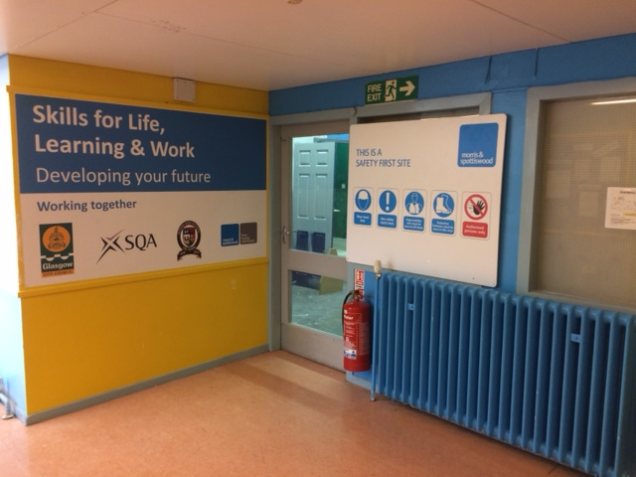

S4 Pre-Apprentice Programme - Construction (National 5)
This course prepares young people considering a career in the construction industry. In this course they will complete units in: Bricklaying; Painting and Decorating; Plumbing; Bench Carpentry; and Employability Skills. There will also be a spell of work experience with a construction company. By participating in this course our pupils will be better placed should they decide to leave school at the end of S4 and intend applying for an apprenticeship. It is also a good lead in to the construction course offered in S5/6 for pupils wanting to further develop their skills and experience in construction.

S5/S6 Graphic Communication (Higher)
This course provides opportunities for learners to initiate and develop their own ideas graphically. It allows them to develop skills in reading and interpreting graphics produced by others and to continue to develop awareness in often complex graphical situations, expanding their visual literacy.

S5/S6 Practical Metalwork (National 4 and 5)
This course enables leaners to gain skills in metalworking techniques and in measuring and marking out metal sections and sheet materials. Leaners develop safe working practices in workshop environments, practical creativity and problem-solving skills, and knowledge of sustainability issues in a practical metalworking context.

S5/6 Pre-Apprentice Programme – Construction National Progression Award (Level 5)

This course prepares young people considering a career in the construction industry and focuses on Painting and Decorating; Employability Skills; and Health and Safety issues. There will also be a spell of work experience with a construction company. In addition pupils will put their practical skills to test around the school by carrying out “real” situation work based activities. The qualification achieved in this course is in line with the vocational qualifications of the first year of an apprenticeship.

Science is an engaging practical based subject where pupils learn through experimentation and problem solving. Pupils study all 3 Sciences over 6 week blocks to give them an opportunity to experience all fields of Science.
Within S1 and S2 you will cover the following topics whilst completing experiments, research tasks and outdoor learning. Each topic will include homework exercises and an end of unit assessment.

S1:
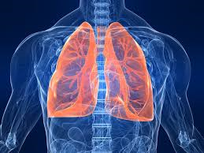
Body Systems Chemical Reactions Heat and Energy

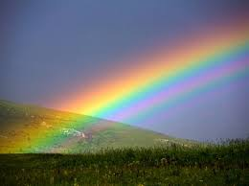
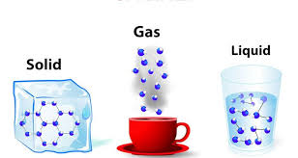
Cells and Reproduction Matter Light and Radiation

S2:
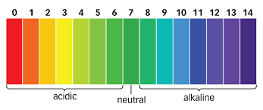
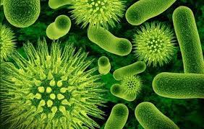
Microbiology Acids and Alkalis Electricity

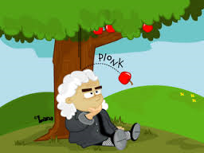
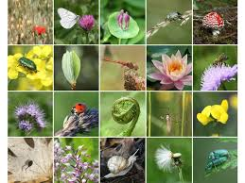
Biodiversity Earth’s Materials Forces

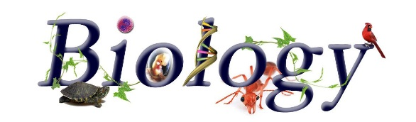
Pupils are interested in Biology as it answers questions about the human body, its complex make up and functions. This genuine interest in how the body works means that pupils are automatically engaged and ask great questions. Pupils investigate concepts via experimentation, which overall leads to great attainment opportunities in the subject. The focus on general Biology also allows exploration of other avenues of life including plants and animals.
National 3/4 | National 5 | Higher
Unit 1: Cell Biology  Unit 2: Multicellular Organisms  Unit 3: Life on Earth | Unit 1: Life on Earth  Unit 2: Multicellular Organisms  Unit 3: Life on Earth | Unit 1: DNA and Genome  Unit 2: Metabolism and Survival  Unit 3: Sustainability and Interdependence
3 periods a week  Homework issued on fortnightly basis  End of Unit Assessments | 4 periods a week  Homework exercise on weekly basis  Mid Unit and End of Unit Assessments | 6 periods a week  Homework exercise on weekly basis  Mid Unit and End of Unit Assessments
Added Value Unit (AVU) researching a key area of Biology and producing a written report | Exam: 20 MCQ and 60 marks Short Answer Questions  Assignment 20 Marks  TOTAL = 100 Marks | Exam: 20 MCQ, 80 marks Short Answer Questions  Assignment 20 Marks  Total = 120 Marks

Biology is extremely content heavy so emphasis is on creating memorable learning experiences which pupils can rely on come exam time. Where applicable, experiments are used as the main teaching method and active learning is used to teach difficult concepts for which experiments are unavailable for. Biology lends itself to outdoor learning and this is taken further attending University labs, Science centre, Zoo Projects etc. Personalisation and choice is available for pupils during research projects and assignments, so pupils can explore topics of interest. Pupils also build on interdisciplinary skills such as literacy (report writing) and numeracy (problem solving).
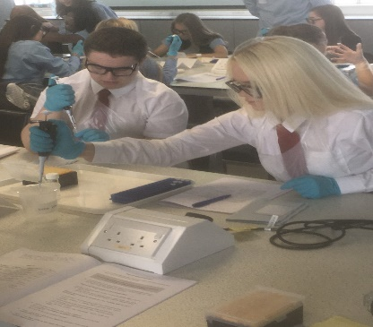
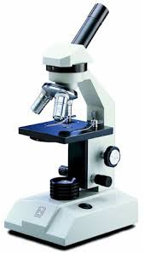
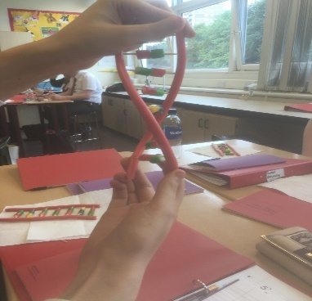

The aim is to create a love for Biology which pupils carry with them through school and on to University, College or potential career opportunities.

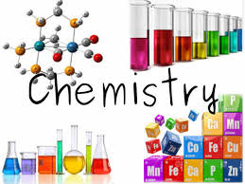
Chemistry is a fun and exciting subject, full of interesting concepts that will allow you to challenge yourself and develop a large variety of skills. Studying Chemistry will open many opportunities for you beyond your school years. Whether you want to go to University to study medicine, veterinary, nursing, forensics or you would like to go to college to study hairdressing, beauty or a cooking course, either way Chemistry is the Science that will stand you in good stead for your future career.

As you progress through the levels in Chemistry you will cover a variety of topics which you can relate to from your everyday experiences. Through studying Chemistry you will be able to enhance your knowledge and understanding of the world around you and develop your problem solving, investigative and practical skills.

S3 BGE Personalisation: You will experience an experimental and investigative approach to develop your knowledge and understanding of Chemistry. You will begin to develop the skills you will require to study Chemistry in your senior years e.g. applying, understanding, decision making and many more.

National 4 and 5 Chemistry: From understanding the periodic table to how perfumes have their smell, the courses offer you a wide variety of knowledge which you will find extremely interesting. On top of the course work you will complete research tasks, practical work and write an assignment which will count for your final qualification.

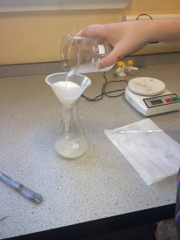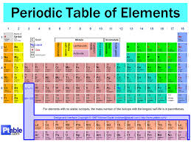

Higher Chemistry: At Higher level you will extend your knowledge and understanding that you will have developed at National 5. Unit 1 (Chemical Changes and Structure) focus’ on reactions rates, enthalpy and patterns in the periodic table. Unit 2 (Nature’s Chemistry) will allow you to realise the importance of organic chemistry in our everyday lives e.g. why do certain foods go off quicker than others? Why does a substance have a distinct flavour? Unit 3 (Chemistry in Society) looks at a variety of calculations which allows you to develop your numeracy and problem solving skills. You will also look at the large variety of practical techniques that can be used within laboratory environments which is particularly useful if you plan to study Chemistry at University.

Assessment: At all levels you will complete short class tests throughout the year as well as completing SQA required assessment components. All courses will involve homework tasks, which are used to promote a positive work ethic and support your revision in preparation for exams.

Physics

Do you want to investigate the limits of space, the beginning of time and everything in between? How about understanding how the technology around you works? Want to save the planet , become an engineer or maybe just help people get better when they are ill by developing nanobots to target cancer cells , Physics has revolutionised the diagnosis and treatment of illness and is at the forefront of medical technology. Or maybe you are not particularly interested in any of this well it doesn't really matter. Whatever you do the knowledge and skills you gain by studying physics will be useful. Physics is more than a subject - it trains your brain to think beyond boundaries. Physics provides such a broad training that whatever career you have in mind, physics will stand you in good stead.
All employers value the skills that physics develops: an ability to grasp things quickly, a determination to find coherent answers, along with problem-solving, analytical, mathematical and IT skills.
Studying physics is an excellent way of keeping your options open. Whether you want to pursue a career in games design (software engineering), in the world of finance modelling the trends in stocks and shares, or sports design - understanding physics is important.

National 3/4 | National 5 | Higher
Unit 1: Dynamics & Space  Unit 2: Waves & Radiation  Unit 3: Electricity & Energy | Unit 1: Dynamics & Space  Unit 2: Waves & Radiation  Unit 3: Electricity & Energy | Unit 1: Our Dynamic Universe  Unit 2: Electricity  Unit 3: Particles & Waves
3 periods a week  Homework issued on fortnightly basis  End of Unit Assessments | 4 periods a week  Homework exercise on weekly basis  Mid Unit and End of Unit Assessments | 6 periods a week  Homework exercise on weekly basis  Mid Unit and End of Unit Assessments
Added Value Unit (AVU) researching a key area of Physics and producing a written report | Exam: 20 MCQ and 60 marks Short Answer Questions  Assignment 20 Marks  TOTAL = 100 Marks | Exam: 20 MCQ, 80 marks Short Answer Questions  Assignment 20 Marks  Total = 120 Marks

Physics is an incredibly hands on subject where pupils have numerous opportunities to take part in active learning and experimental work which will deepen their knowledge and understanding of the topics being covered. Pupils are given control of their own learning by devising their own experiments, research tasks and assignments. This allows for them to develop not only literacy and numeracy skills but also learn to work as part of a team.

Home Economics not only provide our young people with vital skills for living, but it also offers many transferable skills when choosing a career path.

Listed below are a few examples of career opportunities where Home Economics or Hospitality has an important part to play:

- Hospitality and Tourism (one of the largest industries in Scotland)
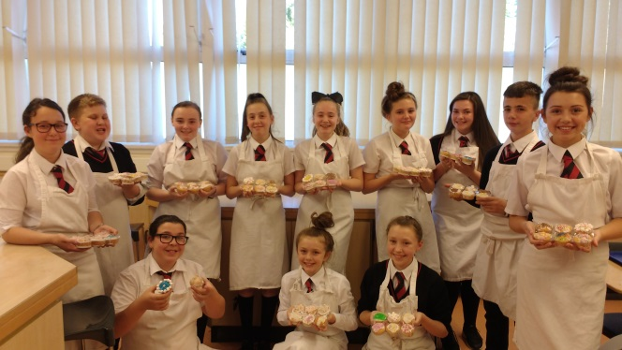
- Health, Nutrition & Dietetics
- Food Product Development
- Education / Teaching
- Social Care
- Consumer & Trading Standards
- Health Promotion
- Nursery Nurse
- Food Safety

S1 & 2 Broad General Education (BGE)
Each year group undertake a number of units.
● Ready Steady Cook – Cooker & Kitchen Safety.
● Ready Steady Eat – Eatwell Plate and Healthy Cooking.
● Design and Make a Pizza – Product Development.
● Foods around the World – Tasting & Creating.
● Design and Make a Cushion – Personalised Designing.
● Nutrient Know How – Healthy Choices & Lifestyles.

3rd year BGE Personalisation (Hospitality)
During this busy year we concentrate on building on our practical skills and increasing our knowledge further in all aspects of Hospitality, the units are
● Smart Cooking – Preparation Techniques and Cookery Processes.
● REHIS Elementary Food Hygiene - Certificate for the Food / Hospitality Employment.
● Getting It Right For All – Nutritional Needs of All & Dietary Diseases

Senior Phase a number of courses are offered…
BGE - Home Economics / Hospitality
Includes REHIS Food Hygiene Certificate

Here are the Progression Routes within the department.

In Nat 5 Hospitality all food preparation techniques are
developed, extended and refined. The cookery processes
are examined and many garnishing styles explored.
Knowledge of ingredients, their functionality, seasonality
and sustainability of these is studied in depth.
All assessment involves practical elements within a set time.
National 4 / 5 Hospitality
Practical Cookery
The National 5 level Exam is to plan, prepare, cook and
present a full 3-course meal for 4 people.
The various courses in Home Economics prepare our
young people for the world of work.
Some of this year pupils are undertaking
the Culinary Excellence Training with the Village Hotel.
National 5
Practical Cake Craft

Next year will see the reintroduction of Nat 5 Cake Craft.

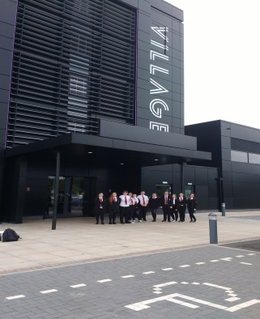

Skills for Work Hairdressing Qualification National 4 (SCQF level)

National 4 Skills for Work: Hairdressing is an introductory qualification. It develops the skills, knowledge and attitudes, needed for work in the industry. These skills are also transferable to other careers.

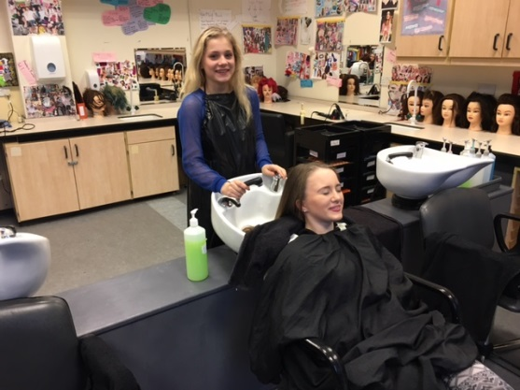

The Course provides a broad, experiential introduction to hairdressing where you will gain experience of general salon duties to support stylists and assisting with customer care. You will learn about the different roles and responsibilities in hairdressing, and begin to develop vocational skills and knowledge. You will develop their skills in shampooing, conditioning and blow-drying hair as well as exploring the creative side of hairdressing, with the opportunity to experiment with style ideas. This course places emphasis throughout all Units on employability skills and attitudes. The specific aims of the course in Hairdressing are to:

- Prepare candidates for work within the hairdressing industry
- Develop hairdressing skills
- Develop good working practises
- Develop an understanding of relevant health and safety issue.
- Develop self-presentation skills.
- Develop a positive and responsible working attitude.
- Develop communication and customer care skills.
- Develop organisational, interpersonal and teamwork skills.
- Encourage skills in setting personal goals, reviewing and evaluating.
- Encourage creativity
- Develop specific and generic employability skills.
- Build candidates’ confidence
- Prepare candidates for further learning opportunities, study and training opportunities in hairdressing

The Intermediate 2 Hairdressing course may therefore provide a variety of progression opportunities. These include: Scottish Vocational Qualification (SVQs) Nat 5 in hairdressing.
- Further education
- Training/ employment.

Physical Education – Broad General Education phase (BGE)

S1/2 courses:
At the start of first year there is an option to apply for the SFA School of football programme. This programme using the medium of football seeks to develop the wider aspects of football such cooperation and teamwork as well as the physical aspects of PE. To accommodate this comprehensive programme the pupils will participate in a restricted core PE programme.

Out with the SFA programme in core PE we are fortunate to have a swimming pool in the school so swimming will feature in both first and second year core PE courses. Core PE in first and second year also consists of blocks of work in the fitness suite, gymnastics, badminton and a range of indoor and outdoor games.

In third year there is an opportunity to choose Physical Education Studies as an option in addition to the core PE periods. The option of taking physical education studies allows the young person to develop in both self-confidence and in physical skill acquisition in a number of areas such as swimming and a variety of sports and activities. A physical education study also develops the knowledge and ability to analyse and develop techniques in several of areas of physical performance.
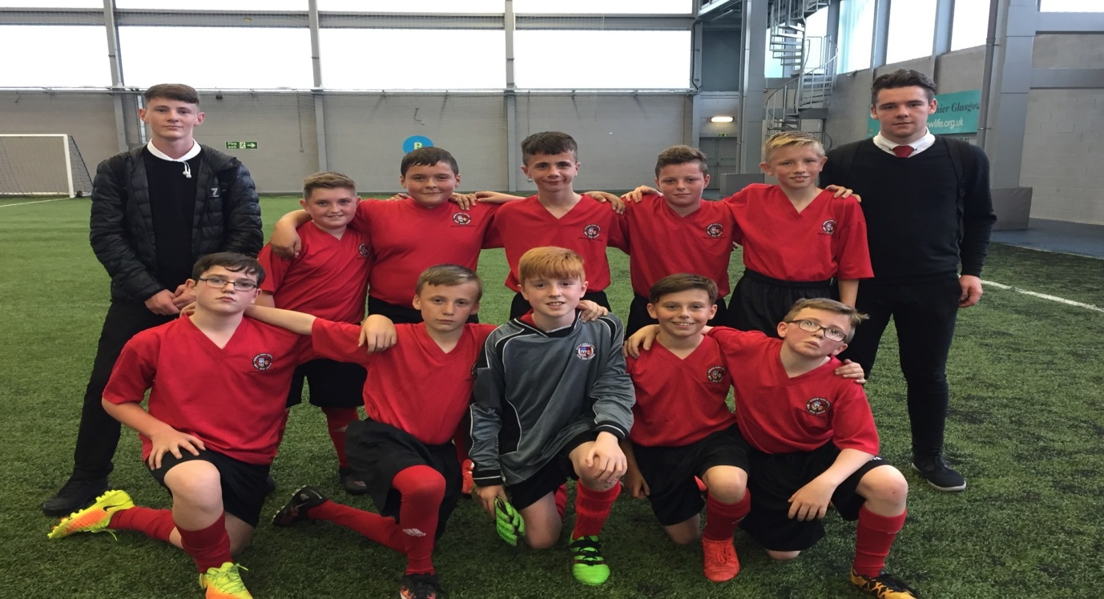

Progression routes in physical education

First Year PE SFA school of football
Level 3
Second Year PE programme

Core PE Dance Leadership PE studies Personalisation choice for
third year
(level 3 and onto level 4 )

In the senior phase (fourth, fifth and sixth year)

Nat 4
Sports Leadership course

Nat 5

Higher

Advanced Higher
(performance unit)
PE Studies.

All courses in Physical Education Studies consist of three elements or units practical performance, factors impacting performance and an added value unit. There are criteria for performance at National 3, 4, 5 and Higher.

Practical Performance you will be taking part in:

Badminton Swimming
Basketball Volleyball
In the course component Factors Impacting Performance you will investigate your performance in all activities and complete course workbooks. In the Added Value unit you will submit a portfolio to SQA (40% overall grade) and the portfolio will contain information on how factors have impacted your performance and how you have developed your performance. You will also be assessed in an activity of your choice in a one off high pressure performance (60% overall grade).

Sports Leadership.
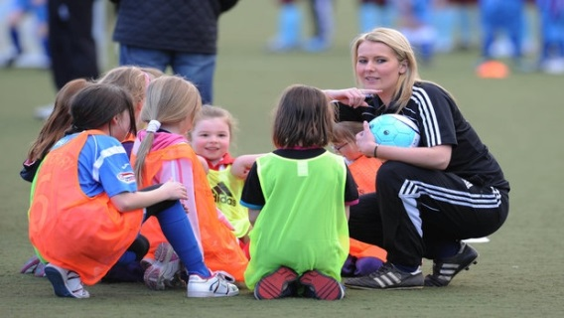
This course is for pupils in the senior phase who are keen to have a career in PE or Sports Coaching and at the end of the year you will receive a SCQF level 4 or 5. This course is ideal if you want to learn to be a coach and lead a sports session. You will also help with primary visits and lower school PE, run PE clubs and help out with teams as well as plan and help run events in the PE department.

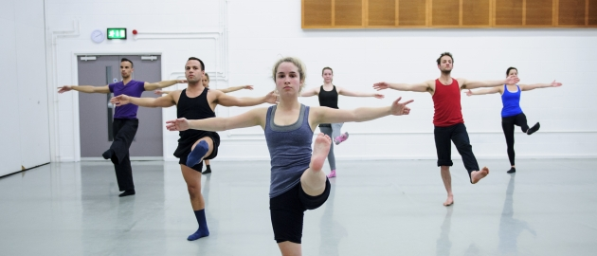

Dance Leadership.
This course is for pupils who have very good participation and effort in Dance. You will keep a diary of what you do in dance and think about how to run a dance session as well as work on your choreography skills. You become a qualified dance coach!

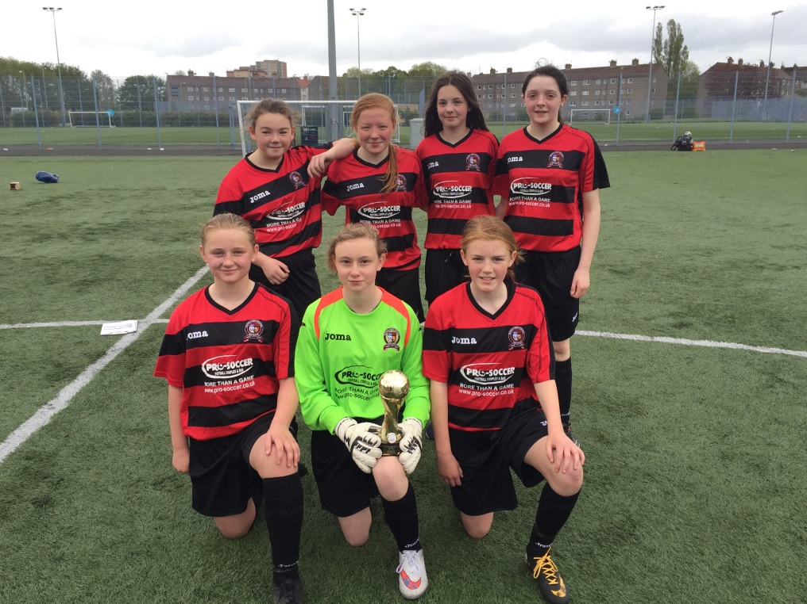

.

Clubs Information
Monday Lunch: Senior Group in Music R. 1; Woodwind Group in Music R. 2; Football Pitch Open; S1-3 Basketball - Gym 3; Trampolining - Gym 1
Monday after School: Boys Fitness - Fitness Suite; Girls Mini Tennis Club – Assembly Hall
Tuesday Lunch: S1-3 Choir in Music R. 1; S1-3 Bench ball - Gym 3
Tuesday After School: S1 Boys Football (at Toryglen); Girls Football (at Toryglen); Swimming Club; Senior Boys Football
Wednesday Lunch: School Band in Music R.2; S1-3 Badminton - Assembly Hall; Young Ambassador meeting - PE classroom
Wednesday after school: Govan Schools’ Pipes and Drums Association - School Assembly Hall; Girls Fitness – Fitness Suite
Thursday Lunch: S1 Library Homework Club - Senior Group in Music R.1
Thursday After School: S1 Cupcake Club Home Ec. - S1-3 Basketball Club - S1-4 Dance Club - Senior Performance Badminton - Senior Basketball Team Practice
Friday Lunch: S2 Library Homework Club - S1-3 Choir in Music R.1 - Percussion Group in Music R. 2 - S1 Futsal Club - Gym 3
Friday after School: Higher PE Supported Study
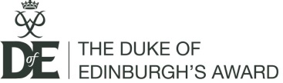
Govan High School offers levels Bronze and Silver of the Award Scheme:
The Duke of Edinbirgh’s Award Scheme is sponsored by the Govan Weavers Society. All pupils are strongly encouraged to partake in the Bronze level, with the Silver following a successful Bronze award. It offers a constructive individual challenge, enjoyable activities and encourages personal development. It also helps to develop initiative and organisation, and always includes an Expedition. The Award is a four section programme with three progressive levels: Bronze, Silver and Gold.

Bronze Award
This involves:
• Volunteering, for 15 hours over three months (helping the community)
• Skills, for three months (a hobby, skill or interest);
• Physical Recreation, for six months (sporting);
• Expedition (on foot) where pupils plan, prepare and undertake a two day and one night venture in the Abefoyle area, supervised by staff. Pupils will also undertake a practice expedition in the previous week. Pupils are required to have completed their Skill, Volunteering and Physical in order to take part in the Expedition, which takes place in the June.
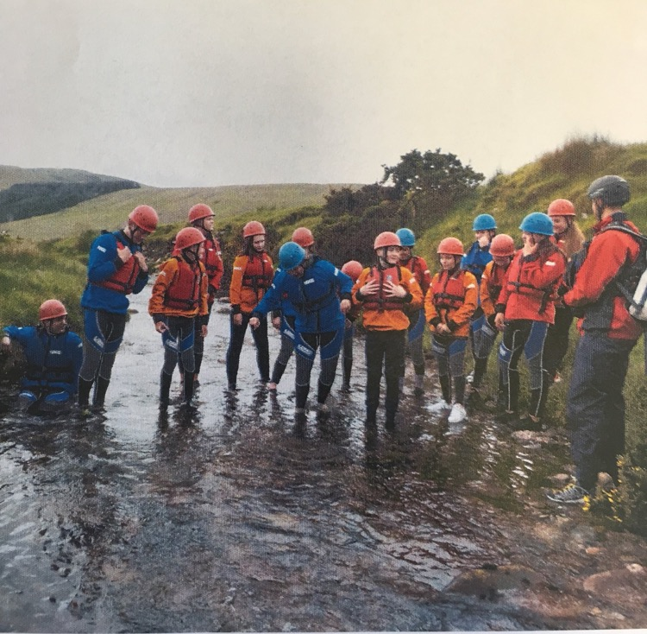

Silver Award
At this level the participants follow a similar format to the Bronze section of the Award. However, the commitment to each section is a further three months. The Expedition section is a three day and two night venture on foot. The expeditions take place in June. Participants who do not hold their Bronze Award must undertake a further three months in either Volunteering or the longer of the Skills/Physical Section. The Silver Award attracts a large proportion of the Fifth Year.
Wider Achievement

The Wider Achievement programme for S1 & S2 is timetabled for one period a week. Wider Achievement activities offer our young people the opportunity to learn team building, communication and life skills, and prepare them for future life challenges. We also regularly celebrate success of our pupils, which helps to develop young people’s self-esteem, confidence and build resilience.
S1 Programme: The S1 wider achievement programme covers many topics that include looking after animals, learning about social media, drama and eco awareness and community projects. The programme also works in partnership with Virgin Money, which involves giving our young people the experience of starting up their own business. Pupils are given £5 each and their task is to make a much profit as possible. These activities lead to the SQA Personal achievement Award
S2 Programme: The S2 wider achievement programme has been designed for our young people to have a mix of wider achievement opportunities and achieve some recognised awards. Pupils in S2 will participate in the Youth Philanthropy Initiative (YPI) which involves our young people identifying a social issue in their local area, researching charities that address the identified social issue and then preparing and delivering a presentation for the local charity. The winning presentation wins £3000 for a local charity; however the process allows our young people to engage in their local community. In S2 pupils will also have the opportunity for personalisation and choice and will be able to choose an activity of interest leading to one of the following awards: Heartstart Award, Playmaker Award, Navigation Award (bronze)
School of Football At Govan High School pupils in primary 7 can apply to be part of the SFA School of Football. The SoF runs in partnership with the Scottish Football Association and Rangers Football club and is funded by Cashback government funding. Pupils involved in the SoF will have five allocated periods, where pupils will develop their football skills as well as life skills. The classroom programme covers topics including numeracy, literacy, nutrition and psychology and leads to the Dynamic Youth Award.
S3 Programme and Senior Phase At the end of S2 pupils will have the opportunity to select a wider achievement opportunity that interests them.

Earl of Wessex The Earl of Wessex Award is a one year award course for 13 year olds. It will lead to the Duke of Edinburgh Award the following year. Pupils will be involved in volunteering, learning a skill, physical exercise and will take part in an expedition. Pupils will have many opportunities to learn outdoors and will be involved in weekend walks. The course leads to the Earl of Wessex certificate / saltire award.
Cadets Govan High School has its own Army Cadet Force which is linked with the local ACF Detachment in Govan. The Army Cadet Force (ACF) is a national youth organisation sponsored by the Ministry of Defence. It offers training and experience based around adventurous sports, promoting achievement, discipline and good citizenship. As one of the UK's oldest, largest and most successful youth organisations, it has a long history of preparing youngsters for all walks of life and encouraging active involvement in local communities. At school level cadets are awarded their Basic stars: 1 star followed by 2 star.
Uniform and Emergency services The Uniform and Emergency Services course allows pupils to study the Services and their importance in the community. Pupils will also look at healthy life style. The course also covers Diversity, Risk assessments healthy living and teamwork. Pupils will visit the Fire Station and Police HQ and meet people who work in the services. The award is SQA National 4.
Dance Leadership The dance leadership programme is designed for pupils who would like to develop their dance skills as well as learning how to lead small groups. Pupils involved in the programme are encouraged to run extra-curricular dance clubs for our younger year groups. This programme leads to the award of Dance leadership level 1 / Saltire Award.
Hairdressing Govan High School has a purpose build hair salon. Pupils who choose hairdressing will learn practical hairdressing and salon management including people skills and financial skills. The course leads to SQA awards at National 4 followed by National 5.
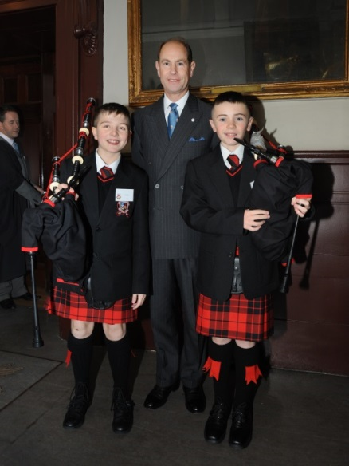
XL Club The XL club works in partnership with The Princes Trust and Glasgow life. Pupils involved in the programme will complete units in the following areas, personal and social development, life skills, community project, enterprise project and preparation for work. Success in XL leads to the award of SCQF Level 3.
Playmaker Award / Practical Performance The Playmaker Award is designed for pupils who would like to develop their own practical performance in sport as well as learning to lead others. The Playmaker award is a good introduction to sports leadership and leads to the Playmaker Award / Saltire Awards.
Sports Leadership The sports leadership programme is for pupils who are keen to have a career in PE or Sports Coaching. Pupils will learn how to be a coach, plan and organise PE sessions, lead sport sessions and help with primary visits. The course leads to the SQA Sports leadership Level 1 / Well-being Award / Saltire Award.
Pre Apprenticeship The course provides a broad experience of a selection of the main trades in the construction industry. The aims of the course are to enable students to develop skills in: LIFE – As well as learning practical skills that can be used and developed throughout your life you will develop other skills such as: Safety in a variety of situations; Teamwork; Organisation; Time Management and much more. LEARNING – which includes literacy, numeracy health & wellbeing, employability, enterprise, citizenship and thinking skills. WORK - Practical experience in trades such as: painting and decorating, joinery, plumbing, bricklaying, tiling and employability skills. A period of work experience related to career choice is also part of the programme. The award is SQA National 4 / 5.
Social Enterprise / Leadership Award Social enterprise will give our pupils an opportunity to identify a social issue and participate in an enterprise project that will support the identified social issue. Pupils will work in teams to research and set up their own social enterprise. SQA Leadership Award level 5 / 6.
Pupil Buddy Pupils in S6 will have the opportunity to be a pupil buddy, which will involve helping S1 pupils with their learning. This is acknowledged by the award of SCQF level 4 volunteering / Saltire Award.
r Achievement Opportunities

Clyde College Schools Prospectus

In addition to the mainstream curriculum, Govan High School offers the opportunity for senior pupils to attend college courses, work experience and other learning experiences offered by partner organisations. Pupils choosing any course in this wider achievement option (Tuesday & Thursday afternoons) also have to do 2 periods a week overtaking the learning outcomes for the National Progression Award: Enterprise and Employability.
Courses offered by Clyde College are as follows:
National Progression Award: Computer Networks and Systems
National Progression Award: Legal Studies
Higher Psychology
Photography SQA Higher
Photography Digital Imaging N5
National Progression Award
Skills for Work: Early Education and Childcare
Skills for Work: Health Sector
Skills for Work: Laboratory Science
Fashion Design Higher
Jewellery Design Higher

Work Experience: Pupils can choose to do work experience on Tuesday and/or Thursday afternoons instead of picking a class. Work experience placements can be self-found, arranged with partner organisations (e.g. GTG, local nurseries and primary schools) or allocated through Glasgow City Council’s Workit database. Examples of how work experience can be used to enhance learning might range from hairdressing students gaining practical experience through a placement in a salon to science students being placed in the NHS work experience programme. This choice is intended to complement the learner’s other curricular choices and can be highly individualised.

